[TopCoder Direct]
Conceptualization Phase

Conceptualization Document

Template v 1.0

6/9/2012

Medicaid Provider Screening Portal Conceptualization
Table of Contents

1.0 Introduction 3
1.1 Overview of Application 3
1.2 Project Objectives 6
1.3 Assumptions 7
1.4 Limitations 8
1.5 Open Items and Risks 8
2.0 Existing Business Flow 11
3.0 Proposed Workflow 12
3.1 Overview 12
3.2 Context Diagram 14
3.3 High Level Workflow 16
3.4 Use Case Diagrams 28
4.0 Business Requirements 30
4.1 Users 30
4.2 Inputs/Outputs 31
4.3 Dependencies 32
4.4 Task Requirements 34
4.5 Security Requirements 50
4.6 Performance Requirements 51
4.7 Data Migration 51

Introduction

Overview of Application

The client for this project compensates US medical service providers through a program called Medicaid. Medicaid is a healthcare program that is funded by taxes paid by U.S. citizens and it is operated by individual states. Medicaid program provides health benefits to more than 60 million Americans which include children, parents, senior citizens, pregnant women and disabled people.

The current business process requires medical service providers to register themselves in their individual state for compensation under Medicaid program by filling out many forms.

The process of screening claims from service providers is manual. The screener receives an application from a provider. The screener first checks the provider has given all required information and license information. The screener will then verify provider information at several websites. This verification includes provider’s information, like medical license and its validity and background check to see if provider has been involved in any violations or suspensions previously. Also the screener checks if the provider has any criminal history.

If any information in forms is incomplete or incorrect, the screener will interact with provider to correct these. After correcting errors, the provider has to resubmit the application for final screening.

However, the service provider is not comfortable in filling paper forms as they are very inconvenient and error prone. Service providers have to do lot of revisions before going for final submission.

Due to the issues mentioned above, along with several other shortcomings of the current process (explained below), Thus the client has decided to replace the existing manual process with a single automated system.

The main goal of the project is to deliver an efficient solution for implementing automated system to ease the enrollment and screening process. Also the portal will be able to automatically screen potential providers for fraud risk before they are approved for payments.

Thus by creating this new application, the client will be able to save the amount of time that takes to do enrollment and screening manually, also able to reduce maintenance costs associated with the process.

This conceptualization document will capture business processes and requirements necessary for creating the new automated application.

Application Problems

The process of enrollment for each service provider is not easy to follow without a system to support automatic enrollment process. The current process of screening each enrolment is not easy to follow without a system to support automatic screening process.
The current process also requires support to be provided for service providers to help filling enrolment forms. This amount of support and maintenance is costly.
The current process doesn’t work efficiently to screen potential providers for fraud risk before they are approved. Service provider can be of individual or an organization. It is hard to figure out which provider doesn’t have license.

Application Opportunity

Building a new application opens the opportunity to create an automated system and business process for service providers.

The application will also need to handle provider types where licenses don’t exist or are very hard to track down to an individual

There is an opportunity to create flexible application which is able handle all provider type enrolments.

There is no data source that can be used by multiple states of USA for screening the providers. There is an opportunity to create a new data source that can be used by any US states.

Finding fraudulent providers is done manually; thus there is an opportunity to automate the screening process to identify fraudulent providers in early stage of the process. The automation involves queering required websites automatically and eliminate the manual work of the screener through single web-portal providing end users a friendly and easy access (through a standard web-browser).

Enrollment involves filling out forms manually. There is an opportunity to automate the process of enrollment by using online forms.

The new application can provide email notifications on approval or denial of enrolment. So it will be possible to get description of approved details. In case of disapproved, it will be possible to get description of places where errors occurred will be available.

There is an opportunity to build the application which can export enrolment data to various data formats.

There is an opportunity to deliver a fully flexible and extendable application by appropriate architectural decisions (i.e. pluggable modules/interfaces, abstraction of common tasks, decoupling implementation details, etc.). Therefore, the new application can be easily expanded in the future by providing more features like automating generating service stub code, etc.

There is the opportunity to include logging and auditing functionality into the new application to assist in monitoring system use and help with system maintenance.

Return On Investment (ROI)

The client has internal ROI metrics they plan to use. In addition, the return on investment for this project can be determined by:
- Reduced support and maintenance costs resulted in helping service providers to fill forms.
- Reduced time to enroll service provider.
- Reduced time to screen claims by service providers
- Reduce time to find fraud providers
- Increased money savings by finding fraud providers before they get paid.

Definition of Terms and Acronyms

MITA | The Medicaid Information Technology Architecture.  Reference: http://www.medicaid.gov/Medicaid-CHIP-Program-Information/By-Topics/Data-and-Systems/Medicaid-Information-Technology-Architecture-MITA.html
ESB | Enterprise Service Bus.  Reference: http://en.wikipedia.org/wiki/Enterprise_service_bus
HIPPA | Health Insurance Portability and Accountability Act of 1996
NNPES | National Plan and Provider Enumeration System) (CMS) (only if applicable
GUI | Graphical User Interface
CHIP | Children’s Health Insurance Program  Reference: http://en.wikipedia.org/wiki/State_Children's_Health_Insurance_Program
ID | Identification
MPSE | Medicaid Provider Screening and Enrollment.
L E I E | List of Excluded Individuals and Entities
NASA | National Aeronautics and Space Administration
SSDM | Social Security Death Master
WAS | Websphere Application Server
CMS | Center for Medicaid Services
SaaS | Software as a service  Reference: http://en.wikipedia.org/wiki/Software_as_a_service
CoECI | Center of Excellence for Collaborative Innovation
multi-tenant implementation | A single system that can handle any type of service provider
JSF | Java Server Faces
MCP | MediCare Certified Providers
SSDM | Social Security Death Master
L E I E | List of Excluded Individuals and Entities
E P L S | Excluded Providers List System
NNPES | National Plan and Provider Enumeration System
EFT | Electronic Funds Transfer
PEP | Front-end Provider Enrollment Processor
PVS | Provider Validation Service

Project Objectives
The business objectives of this project are listed below. Delivering these objectives will deliver the expected benefits of the application.

- To design an application that will automate the process of screening and enrollment for service providers.
- To design a new portal application that reduces the time needed by service providers to submit application claim forms.
- To design a new application which will improves accuracy in making enrollment decisions.
- To design a new application which will reduces the time required to make enrollment decisions.
- To design and an MITA 3.0 compliant application.
- To design an application that implements a multi-tenant provider screening solution to save administrative/infrastructure costs.
- To design and build a new application that can be integrated into an open source solution that can deliver a reliable, scalable, and cost-effective provider-screening capability US states.
- To design an application that will build a database of service providers for use by any state of USA.
- To design an application that which Improves availability of provider data.
- To design an application that effectively reduces the time need to get details of providers by queering respective data sources regarding provider.
- To design an application that will support Risk-Based Provider Screening for all new and re-enrolling providers.
- To design an application that will improve the ability to implement Affordable Care Act provisions in Medicaid/CHIP.
- To design and build a new application that will have the ability to implement sections 1902(a)(39) and 1902(a)(77) of the Social Security Act, as amended by the Patient Protection and Affordable Care Act (P.L. 111-148 and 111-152) subsections 6401(b) and (c) (Provider Screening and Other Enrollment Requirements Under Medicare, Medicaid, and CHIP), and section 6501 (Termination of Provider Participation Under Medicaid if Terminated by Medicare or Other State Plan).
- To design and build a new application that will help in driving alignment of the Medicaid Information Technology Architecture (MITA) 3.0 framework to the Information and Technology Architecture levels
- To design an application that is deployable as a hosted service offering (SaaS).
- To design an application that nicely integrates with existing systems like license databases.
- To design an application that periodically checks existing systems for updates.
- To design an application that complies with section-508 of the Americans with Disabilities Act requirements.
- To design an application that should pass DHS audit testing.
- To design an application that allows scheduled or immediate payment processing.
- To design an application that is able to do Identity Verification:
- To design an application so as to support easy addition of 'Help Features' later
- To build an application that easily recognizes what applications need to submit an application fee and should be able to collect that fee.
- To design an application that supports multiple user types (roles).
- To build an application with the ability to send email notifications when specific enrolment is submitted, approved or denied.
- To design an application that complies with data privacy standards and other corporate standards.
- To have the application support logging. Save log data of all errors, exceptions, and warnings to log records.
- To save audit records for all activity initiated by the user.
- To save application usage metrics (as part of auditing).
To design an application to have the capability to Conduct Identity Verification
- To design an application to have the capability to Build Provider Profiles
- To design an application to have the capability to Evaluate and Maintain the Integrity of the Results
- To design an application that will allow admin(service and system) to find specific provider information with minimal search attempts
- To design an application to have the capability to identify applicants, including individual providers and owners of institutional providers.
- To design an application to have the capability to verify identity and prior history of problems with Medicaid/CHIP or Medicare programs.
- To design an application to have the capability to identify and schedule revalidation process.
- To design an application which allow changing the language of the application
- To design an application which have the capability to create a learning system to ensure that observed negative trends factor back into screening rules so as to flag suspicious enrollments early in the screening process, ensuring the ability to detect and reduce/eliminate the incidence of false positives

Assumptions
Some assumptions generally must be made in order to write a succinct definition of the application. Some assumptions are technical (e.g. “the new system will employ a normalized database schema”); while others are business natured (e.g. “the client will provide an enterprise Oracle environment”). Assumptions critical to the success of this project are listed below:

- The application will be networked and browser-based.
- The application for this project is new. Hence the architecture and implementation will be fully new.
- Users of the new application will be using a PC, web browser, a keyboard and a mouse (or equivalent).
- Users of the system will have Internet access.
- Users can access the application from multiple US time zones, but that must not affect anything in the application. The application must be time zone agnostic.
- The application does not work with any peripheral devices other than printer and scanner.
- The application will be accessed through secure socket layer (SSL).
- The state of Minnesota will continue using MN-ITS mailbox for sending email notifications and other states may have their own similar system or they can use the application’s email notification service.

Technical Assumptions:
- The application should be built using web application technologies. The application can be developed using the following technology stack:
  - Java Server Faces 2.0 ,
  - WESB,
  - MQ Series 6.0,
  - WebSphere Process server (WPS) 7.0.04
  - WebSphere enterprise Service Bus (WESB) 7.0.04
  - Oracle database11g,
  - limited java services (JAXWS and JAXB),
  - WebSphere service Registry and Repository (WSRR)
  - WAS 7.0.0.21
  - J2EE 6.0
  - JAVA SDK 5.0.22
  - Hibernate 3.6.3
  - Spring 3.0.5
- The application will support all modern browsers: Firefox, Internet Explorer, Safari, and Chrome (specific versions still an open issue).

Limitations
Every project has limitations on the scope of the problem it attempts to solve, on the capabilities of the implementation technology, etc. Some limitations are assumptions on the extent of feature scope. Others are restrictions on resources or methods for achieving the objectives. The limitations of this project are listed below:

- The help features is not defined, this may trouble service providers in understanding the new application.
- The identity and license verification is done by interacting with external systems.
- The setup and management of user roles is out of scope for this project. Both of these security features will be handled by the existing security system.
- Presently, the application will only be available in English. Later it may support multi-language.
- This application will not pay providers. Payment to providers is handled externally or may be through other systems.
- Screening rules are not part of this contest definition.

Open Items and Risks
During the conceptualization of the project and in the process of writing this document, some issues may have been discovered, and others may remain open.

Open Items and Risks for the Next Phases of the Application

- The look and feel of the application is not yet defined. TopCoder Studio contests may be run to define the look and feel.
- The new system must be designed so as to support easy addition of 'Help Features' later. How this can be done will be decided in architecture contests.
- The new application is required to work properly for all modern browsers (FF, IE, Safari, Chrome). However, the exact version of these browsers to be supported has not yet been defined. This will need to be defined in the specification or architecture phase of the project.
- Not knowing the details of how the existing authentication system works is a risk to the project. Especially in regards to user roles management since this project has many user roles and functionality dependent on them. How the geography (user state) of the user is provided by the existing authentication system also needs to be defined since this is also used to determined provider types in the application for this project.
- Not knowing the details of how the interaction with license system should work is a risk to the project.
- The users will have the ability to use browser print functionality to print data displayed by the application. How this information is displayed to be considered printable needs to be defined before the start of the specification or architecture phase of the project.
- The data privacy standards and other corporate standards the application needs to comply with must be provided by the client. These items must be defined before the start of the specification or architecture phase of the project.
- Collection of application fee where ever applicable is yet to be determined. This will need to be defined in the specification or architecture phase of the project.
- The new application will able to handle any type of service provider (individuals, organizations, Physicians etc…)
- The new application must integrate with the existing security system. Architect has to elaborate on this.
- The new application must integrate with the existing data sources. Architect has to elaborate on this.
- How exactly the Integration of the new system will be accomplished with the existing systems is yet to be identified.
- It is suggested that new application can follow the logical modules design at
http://apps.topcoder.com/wiki/display/docs/Medicaid+Provider+Enrollment+Screening+Modules
- The new application that will support “Risk-Based Provider Screening” for all newly enrolling providers and re-enrolling providers (according to the new regulations effective from March 25, 2011, under Medicare, Medicaid and CHIP)
- The new application is able to implement sections 1902(a)(39) and 1902(a)(77) of the Social Security Act, as amended by the Patient Protection and Affordable Care Act (P.L. 111-148 and 111-152) subsections 6401(b) and (c) (Provider Screening and Other Enrollment Requirements Under Medicare, Medicaid, and CHIP), and section 6501 (Termination of Provider Participation Under Medicaid if Terminated by Medicare or Other State Plan).
- To design and build a new application that will help in driving alignment of the Medicaid Information Technology Architecture (MITA) 3.0 framework to the Information and Technology Architecture levels. More details of MITA 3.0 are yet to be provided.
- To design and build a new application that can be deployed as a shared service. The new application must be deployable as a hosted service offering (SaaS). Architect has to elaborate on this.
- To design and build a new application as an integration target, in order to integrate with existing systems. Architect has to elaborate on this.
- To design and build a new application as that scales well as the application load increases. Architect has to elaborate on this.
- Compliance with MITA 3.0 architecture/framework must to be elaborated by the Architect.
- Compliance with the US Section 508 of the Americans with Disabilities Act requirements must be elaborated by the Architect.

Open Items and Risks for the Future / Next Versions of the Application
- To support “nice to have” objectives if they were not achieved in the current version of the application.
- In the future, the application may need to include multi-language support
- All the screening rules are out of scope of this contest and will be handled in future contests.

Existing Business Flow

If this is an entirely new application, this section should be completed only if there is an existing business process.

This project is for a new application so this section is not necessary (as confirmed by the client).

Proposed Workflow

Overview
This section includes a concise description of the features and operation of the proposed solution. It also compares and contrasts the solution with the current process. The context and workflow of the proposed solution are defined in subsequent sections.

The new application will replace the existing manual process with a single, user-friendly web application.

The new application will be a web-based application which will allow providers to enroll by filling application forms. The new application will be able to identify potentially high risk registrants by looking in to past history and type of business.

The new application will be able to determine the difference between an individual and an organization based on profile information filled in enrolment form. The new application will be a multi-component application. The first component serves as an entry portal gateway for all downstream processing efforts and therefore is expected to be robust, intelligent, and comprehensive in its data collection process.

The second component will be a highly efficient validation processing service which receives the input data and ensures the integrity of the enrolling/re-enrolling entity. The other components would involve the degree of automation and the robustness of the data repository.

Compliance with section 508 Standards
The new application will be in compliance with section 508 of the Rehabilitation Act of 1973 which requires that when Federal agencies develop, procure, maintain, or use EIT, Federal employees with disabilities have access to and use of information and data that is comparable to the access and use by Federal employees who are not individuals with disabilities, unless an undue burden would be imposed on the agent. The following is the summary of section 508 standards the new application should comply with:

Section 508 Standards

Subpart - A (General)

1194.1 Purpose
1194.2 Application
1194.3 General Exceptions
1194.4 Definitions and
1194.5 Equivalent Facilitation

Subpart - B (Technical Standards)

1194.21 Software applications and operating systems
1194.22 Web-based intranet and internet information and applications
1194.23 Telecommunications products
1194.24 Video and multimedia products
1194.25 Self contained, closed products
1194.26 Desktop and portable computers

Subpart - C (Functional Performance Criteria)

1194.31 Functional performance criteria.

Subpart - D (Information, Documentation, and Support)

1194.41 Information, documentation, and support.

(Includes Figures to Part 1194)

Please note that Section 508 does not apply to national security systems, as that term is defined in section 5142 of the Clinger-Cohen Act of 1996 (40 U.S.C. 1452).

More information on section 508 can be found here

Compliance with MITA Framework

The application is expected to be in compliance with MITA Framework. MITA defines a series of interoperability services based on Web Services (WS) and Extensible Markup Language (XML) message formats and protocols. The tools States need to establish interoperability, data capabilities, and other support requirements are available individually to States in groups using common facilities.

The figure below depicts some of the fundamental pieces of a SOA-based Business Service. Each service has Interface Components that include security attributes that inspect incoming messages to verify the message originator has authorization to invoke the service (e.g., only designated Medicaid staff members have authorization to approve claims.)
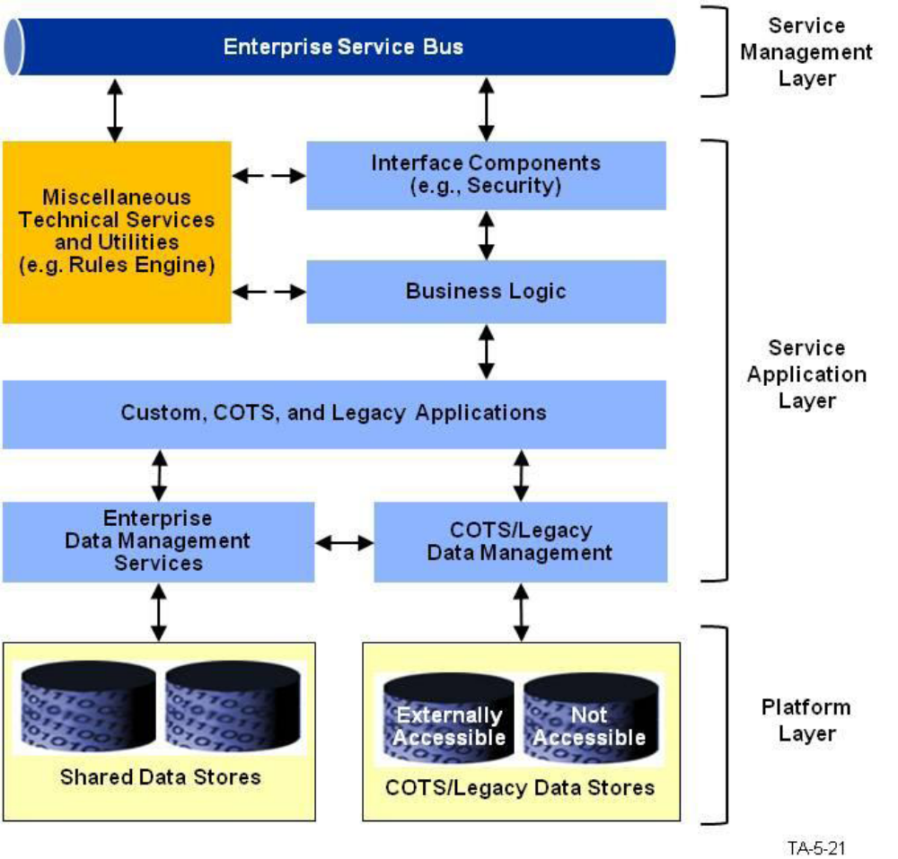

Provider Enrollment Processor (PEP):

The PEP is the front-end Provider Enrollment Processor which is responsible process enroll and for existing providers seeking re-enrollment. It serves as both the brains and the gatekeeper for all downstream processing as data collected in this stage determines what has to take place at the various junctures to comply with the screening regulations.
PEP utilize 'smart technology' and business rules to collect the appropriate needed information and direct the enrollee to the various areas of the application to be completed based on parameters such as provider type or level of assigned risk (Limited, Moderate, or High).

The actual implementation of PEP is not in scope of this contest. Following contest will handle this.

Comparison with Old Approach

The current process of enrolling providers is done manually by filling lot of paper forms. The human errors are quite frequent with this process.
- In contrast, the new application will automate the process of enrollment and will eliminate the possibility of human errors.

The current process of finding fraudulent providers is done manually which is time consuming and not efficient as human error are prevalent.
- In contrast, the new application will automate the process of screening and thereby decreasing the processing and eliminates the possibility of human errors.

The current process of finding fraudulent providers happens only after payments made to service providers.
- In contrast, the new application will identify potential fraudulent providers in initial stages by looking in to provider history, service type and other through automation system.
Currently there is not permanent data storage exists for providers which can be used by other states to screening needs.
- In contrast, the new application will create a database of providers that can be used by other US states.

The current process of queries other websites or data source to retrieve providers identify or license information is done manually.
- In contrast, the new application will be integrated into existing external systems so that queering can be made automatic.

The current process of collecting fees for enrollment is done manually,
- In contrast, the new application will be able collect fees from providers through automated system.

New System Features

The new system will have some of the important capabilities as described below:

- Capability to Conduct Identity Verification
- Capability to Build Provider Profiles
- Capability to Evaluate and Maintain the Integrity of the Results
- Capability to identify applicants, including individual providers and owners of institutional providers.
- Capability to verify identity and prior history of problems with Medicaid/CHIP or Medicare programs.
- Capability to identify and schedule revalidation process.

System Features (user roles perspective)

The Service Provider and the Service Agent user roles can perform the following actions:
- Login, Logout, View Home Page, Get Help
- Manage Enrolments: which includes Creating New Enrolment, Updating Enrolment, Viewing Enrolment, Querying Enrolment Status and Exporting Enrolment Data.
- Manage Renewals: which includes Creating Renewal Enrolment, Updating Renewal Enrolment, Viewing Renewal Enrolment and Exporting Renewal Enrolment Data.
- View Profile and Update Profile.

The Service Administrator can perform all actions that a service agent can perform; additionally the Service Administrator can perform following actions:
- Perform Screening: which includes initiating On-Demand Screening, Scheduled Screening and Re-Validation.
- Searching Enrolments
- Overriding Previously Denied Applicant Status

The System Administrator can perform all actions that a Service Administrator can perform; additionally the System Administrator can perform following actions:
Manage Users: which includes Creating New User, Deleting User and Manage User Permissions.

Proposed Solution

The new application will allow the potential or existing providers to select their provider type and based on the selected provider type the application will display appropriate forms to the users. The users fill out the forms online and will be able to submit the completed forms after accepting the relevant terms and conditions. The users will also be able to print the completed and submitted application form.

The application will collect the Applicant’s data that was entered in the user form(s). The application will also collect payment. The application will analyze the results obtained from the PVS and will assign a ‘Risk Category’ to the applicant. There are specifically three risk categories: Limited, Moderate and High.

Once, the applicant approval/denial status has been determined; if the applicant is approved, then a notification is sent to the email address of the provider mentioned during the registration process. Then, the application will save the approved status to the applicant’s profile. On the other hand, if the applicant is denied, the reason for denial along with the applicant data will be written out to a separate database to be shared by other entities.

The new application will create Provider Profiles upon initial registration of users; the users will be able to view their profiles and can submit profile changes. When profile changes are submitted by any provider, the system will notify this event. (Please note it is not yet identified which user role will receive this notification email).

Additionally, the new application will be able to interface with external license databases, and will be able to run screening process when there are changes to the license status, either automatically or from a scheduled monthly check. The new application will have the ability to do monthly checks of sanction and license boards, as well as anytime when required. Either scheduled or on-demand.

The new application will support multiple user roles (see section 4.1 for complete details). Users will have access to functionality based on their user role, permissions (Note: complete details about each role are yet to be provided).

The new system will integrate with the existing authentication system. User access to system functionality will be limited based on user type (see section 4.1 for more details) and user location.

The new system will integrate with the existing license database system.

This new application is able to reduce the time it takes to submit enrollment information.
This new application saves administrative/infrastructure costs by providing a multi-tenant provider screening solution.

This new application will display appropriate forms to users based on their provider type.

This new application will identify and collect form fee when applicable.

This new application will collect and save the applicant’s data to the database.

This new application will keep the service provider information in database to be available for access to other US states.

This new application will automates querying authoritative data sources to verify provider credentials, license and other information.

This new application will query the existing data sources to verify the applicant data for renewal requests and for new enrolments it will query authoritative data sources to verify provider credentials, license and other information.

The application automates enrollment decisions by querying multiple data sources.

The new application will also support logging and audit functionality. The audit functionality will also keep track of usage metrics in addition to user activity.

Context Diagram
The Context Diagram illustrates the modules, business processes, etc that feed or interact with this proposed application.

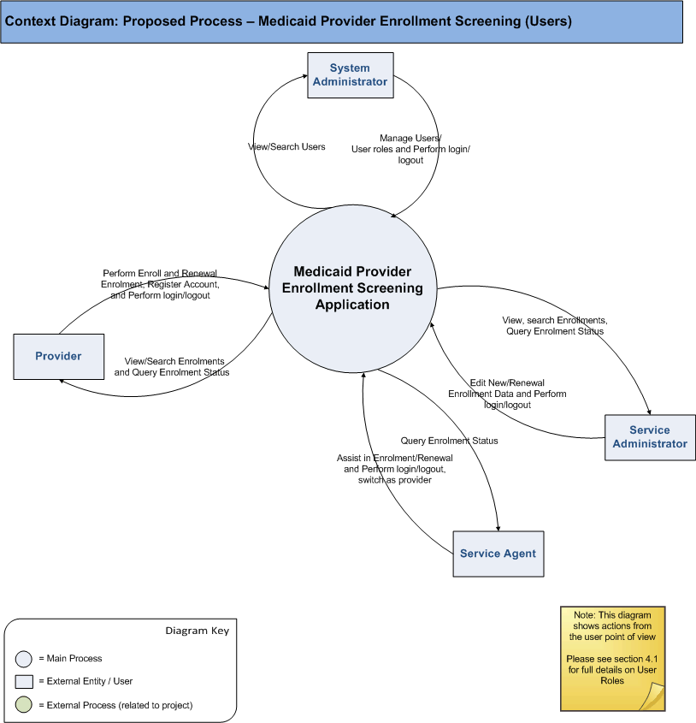

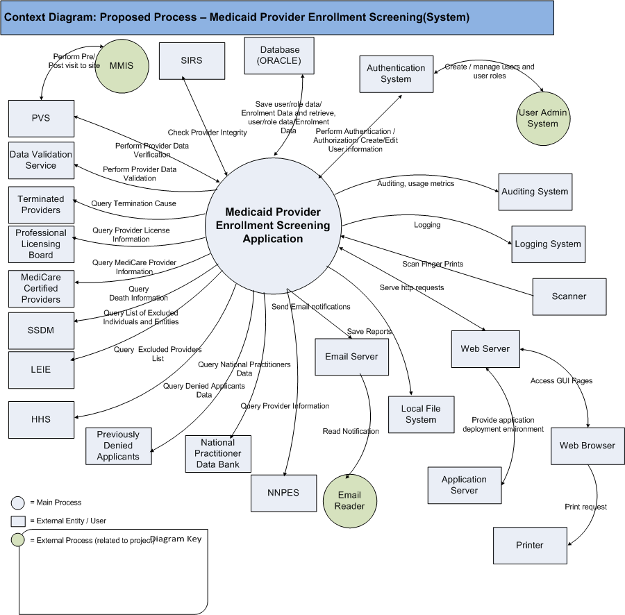

10/11/2012: Update - Service Admin will be able to check the fingerprint status for High Risk providers. There won’t be any fingerprint scanning from the application.

High Level Workflow
The workflow required to complete the primary objectives of the proposed application is described below. The workflow is business-centered, and includes “decision forks” for decisions the business user, or application, must make to achieve the objective. The workflow omits application faults or exceptions. Individual tasks in the workflow are described.

Workflow/Process Map Diagram
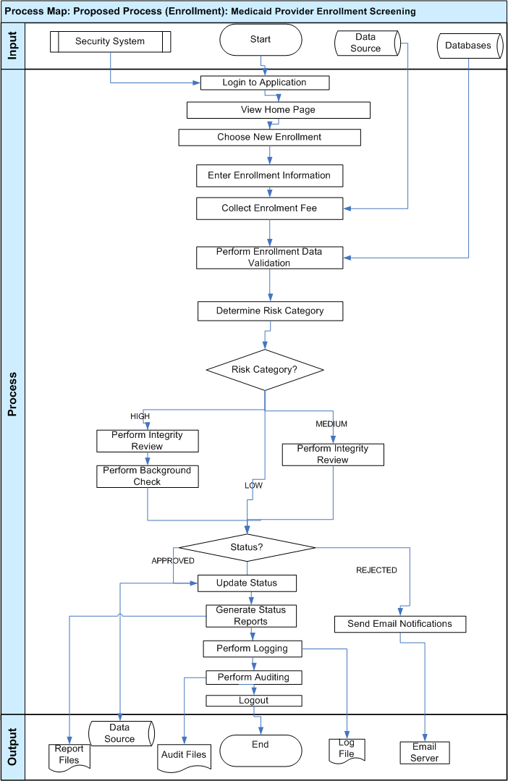

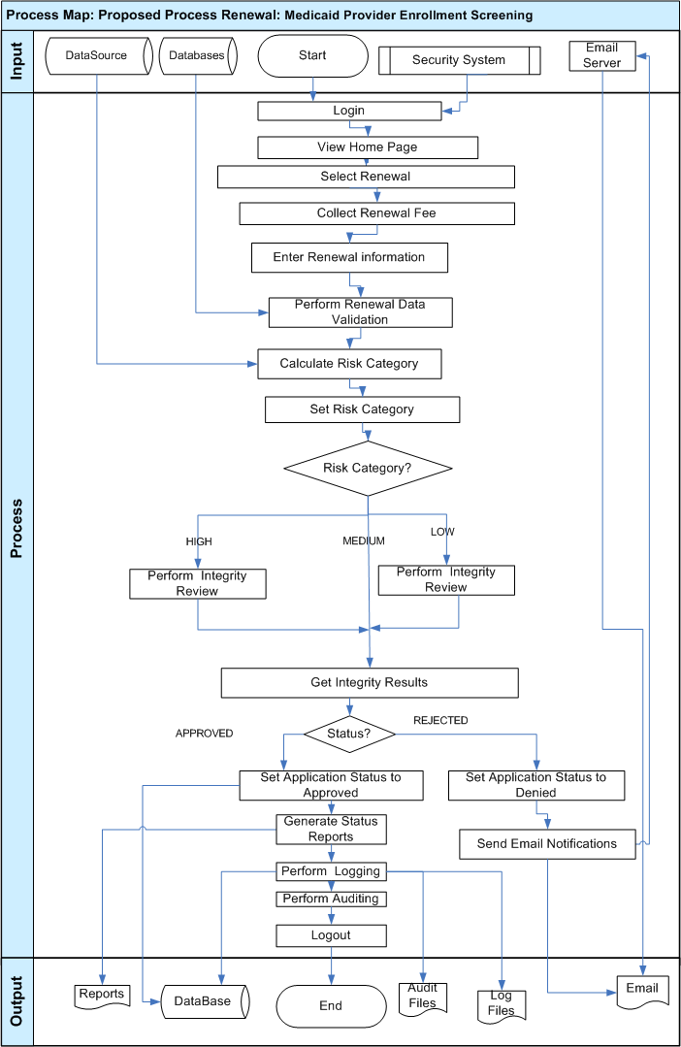
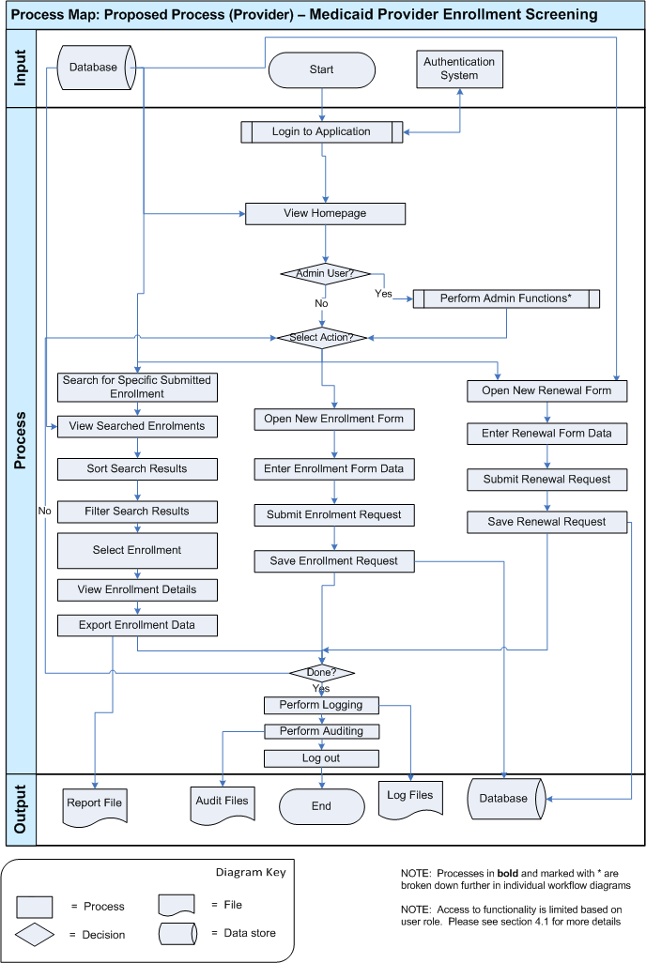
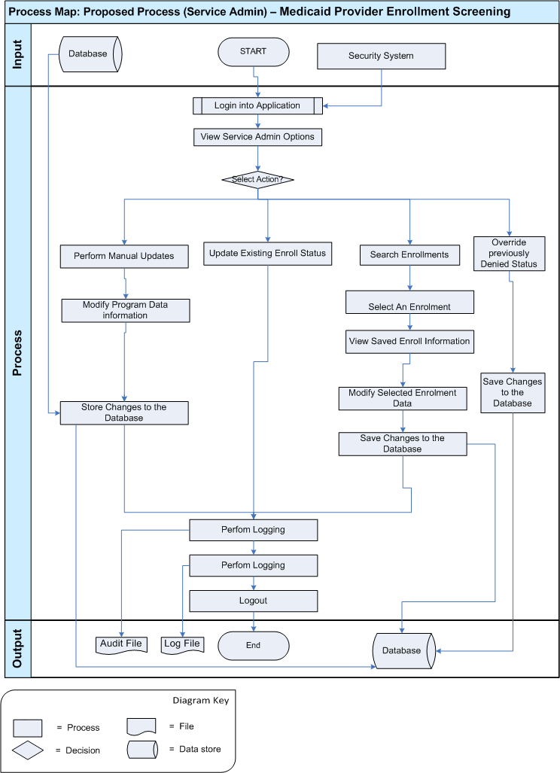
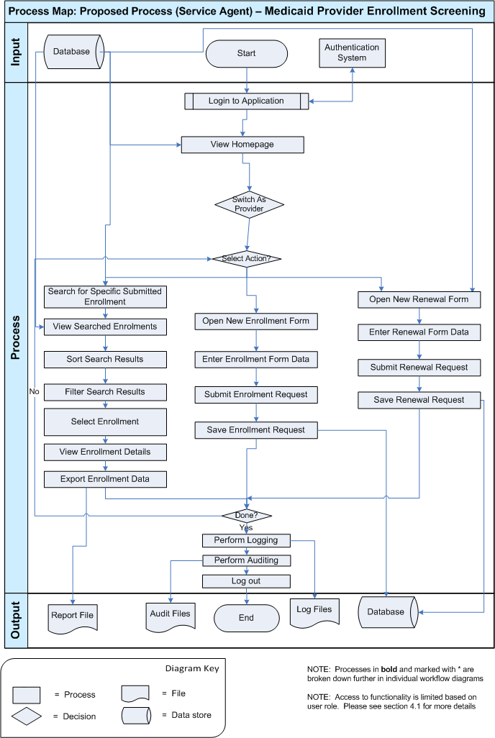
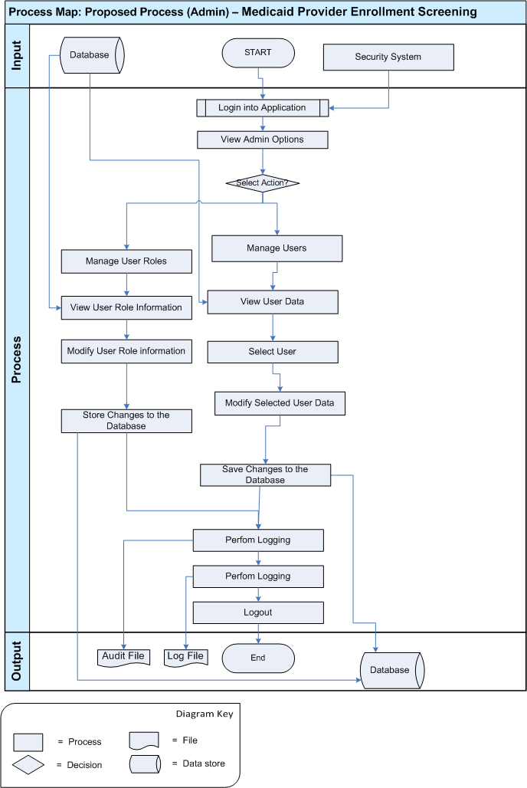

Workflow Description
Enrolment
- The user can login to the application and get access to the application.

  - The user’s credentials are verified using the existing authentication system.
    - For this project the login functionality will be implemented which will interact with existing authentication system.
      - Possible Problem: If the user hasn’t been granted access to the application they will be unable to login.
11/08/2012: Update - There will also be a registration screen in the new application, which will allow the users to register.
  - The level of access available to the user is based on the user’s role
- The application will display the user’s homepage
  - The homepage will display different view on the homepage based on user type
- The homepage will contain summary information about his/her enrolments.
- The home page will contain a link to submit new enrolment.
- The user can select an new enrolment to view its page
- The user can enter enrolment information in new enrolment form
  - Possible Opportunity: The new application will able to figure out the forms required for a provider and on type of enrolment
  - Possible Problem: The forms with provider type and type enrolment are yet to be determined. Thus there is a possibility that incorrect forms may be displayed to providers.
  - The application will collect fee based on provider type and enrolment type
  - The application will perform screening to determine the risk category.
  - The application will interact with several external system to verify the provider
  - The application will use a Provider Validation Service (PVS) to perform validation on provider data to determine the risk category.
PVS interacts with several external databases to perform integrity checks:
- Terminated Providers (i.e. Terminated for cause) (CMS).
- Professional Licensing Board: Dentists, Optometrists, Doctors, etc. (State). (only if applicable)
- MediCare Certified Providers (CMS) (only if applicable)
- SSDM: (Social Security Death Master) (SocSecAdmin)
- L E I E: (List of Excluded Individuals and Entities) (OIG)
- E P L S: (Excluded Providers List System) (HHS)
- NNPES: (National Plan and Provider Enumeration System) (CMS) (only if applicable).
- Previously Denied Applicants.
- National Practitioner Data Bank.
    - Possible problem: the risk level determine may not be accurate. This is possible if the screening rules are not perfect. Enough. Hence, the application also needs to verify whether each rule is appropriate or not for the current provider type and enrolment type.

  - Once, the risk category is determined, the application again perform integrity checks to reject/accept the application
    - Integrity Check ( SIRS)
If the risk category is ‘HIGH” or ‘MEDIUM’, the application requests the SIRS to perform an integrity check.
- Check Criminal Background
After receiving results from SIRS, the application addition checks like checking criminal background. This process may include contacting provider local police department and FBI for verifying user finger prints.

  - After successfully verifying enrolment data and provider identification, the application will set the enrolment status to approved or denied.
  - The application will show the enrolment status with appropriate look and feel.
  - Once Risk category is determined,
    - The application will set the appropriate status to enrolment and save it into database
    - The application will send email notifications to provider notifying the status of enrolment
    - The user is able to generate reports from enrolment data.
- When the user is done working they can exit the application
- The user will be logged out and logging and auditing will be completed

Renewal
- This workflow is same as “new enrolment” except that the enrolment type is set to “Renewal”.
- The user can login to the application and get access to the application.

  - The user’s credentials are verified using the existing authentication system.
    - For this project the login functionality will be implemented which will interact with existing authentication system.
      - Possible Problem: If the user hasn’t been granted access to the application they will be unable to login.
  - The level of access available to the user is based on the user’s role
- The application will display the user’s homepage
  - The homepage will display different view on the homepage based on user type
- The homepage will contain summary information about his/her enrolments.
- The home page will contain a link to submit renewal enrolment.
- The user can select a “renewal” to view its page
- The user can enter enrolment information in new renewal enrolment form
  - Possible Opportunity: The new application will able to figure out the forms required for a provider and on type of enrolment
  - Possible Problem: The forms with provider type and type enrolment are yet to be determined. Thus there is a possibility that incorrect forms may be displayed to providers.
  - The application will collect fee based on provider type and enrolment type
  - The application will perform screening to determine the risk category.
  - The application will interact with several external system to verify the provider
  - The application will use a Provider Validation Service (PVS) to perform validation on provider data to determine the risk category.
PVS interacts with several external databases to perform integrity checks:
- Terminated Providers (i.e. Terminated for cause) (CMS).
- Professional Licensing Board: Dentists, Optometrists, Doctors, etc. (State). (only if applicable)
- MediCare Certified Providers (CMS) (only if applicable)
- SSDM: (Social Security Death Master) (SocSecAdmin)
- L E I E: (List of Excluded Individuals and Entities) (OIG)
- E P L S: (Excluded Providers List System) (HHS)
- NNPES: (National Plan and Provider Enumeration System) (CMS) (only if applicable).
- Previously Denied Applicants.
- National Practitioner Data Bank.
    - Possible problem: the risk level determine may not be accurate. This is possible if the screening rules are not perfect. Enough. Hence, the application also needs to verify whether each rule is appropriate or not for the current provider type and enrolment type.

  - Once, the risk category is determined, the application again perform integrity checks to reject/accept the application
    - Integrity Check ( SIRS)
If the risk category is ‘HIGH” or ‘MEDIUM’, the application requests the SIRS to perform an integrity check.
- Check Criminal Background
After receiving results from SIRS, the application addition checks like checking criminal background. This process may include contacting provider local police department and FBI for verifying user finger prints.

  - After successfully verifying enrolment data and provider identification, the application will set the enrolment status to approved or denied.
  - Once Risk category is determined,
    - The application will set the appropriate status to enrolment and save it into database
    - The application will send email notifications to provider notifying the status of enrolment
    - The user is able to generate reports from enrolment data.
- When the user is done working they can exit the application
- The user will be logged out and logging and auditing will be completed

Provider – Main WorkFlow
- The user can login to the application and get access to the application.
  - The user’s credentials are verified using the existing authentication system.
    - For this project the login functionality will be implemented which will interact with existing authentication system.
      - Possible Problem: If the user hasn’t been granted access to the application they will be unable to login.
  - The level of access available to the user is based on the user’s role
- The application will display the user’s homepage
  - The homepage will display different view on the homepage based on user type
- The homepage will contain summary information about his/her enrolments.
- The homepage will also contain highlight items that require the user’s attention
- The user can select individual enrolments to view from their homepage.
- The user can select an individual enrolment to view it from their homepage
- The user can select an Open New enrolment to register new enrolment.
- Refer to Enrolment workflow
- The user can select an Open New Renewal to renew an existing enrolment
- Refer to Renewal workflow
- The user can select to search for specific enrolment data
  - The user will enter the information they wish to search for
    - Possible Bottleneck: If the user enters a broad search query it may take a long time to process all of their results.
    - Possible Bottleneck: There can be a performance bottleneck if too many users are performing very complex searching at the same time. In this case, new search requests can be queued, postponed and not processed until all the earlier requests are processed. This bottleneck can be reduced by caching and more effective data queries.
    - Possible Opportunity: To provide simple instant searching for the most common situations and a powerful flexible searching for more detailed and complex retrieval of the needed data.
  - The application will display search results
  - The user can select to sort or filter their search results
  - The user can select to view the details for a specific enrolment forms.
- The user can views / manage enrolment details
- When the user is done working they can exit the application
- The user will be logged out and logging and auditing will be completed.

Service Agent
- The user can login to the application and get access to the application.
  - The user’s credentials are verified using the existing authentication system.
    - For this project the login functionality will be implemented which will interact with existing authentication system.
      - Possible Problem: If the user hasn’t been granted access to the application they will be unable to login.
  - The level of access available to the user is based on the user’s role
- The application will display the user’s homepage
  - The homepage will display different view on the homepage based on user type
- The homepage will contain summary information about his/her enrolments.
- The homepage will also contain highlight items that require the user’s attention
- The service agent can switch to other provider account and perform operations on behalf that provider.
- The user can select individual enrolments to view from their homepage.
- The user can select an individual enrolment to view it from their homepage
- The user can select an Open New enrolment to register new enrolment.
- Refer to Enrolment workflow
- The user can select an Open New Renewal to renew an existing enrolment
- Refer to Renewal workflow
- The user can select to search for specific enrolment data
  - The user will enter the information they wish to search for
    - Possible Bottleneck: If the user enters a broad search query it may take a long time to process all of their results.
    - Possible Bottleneck: There can be a performance bottleneck if too many users are performing very complex searching at the same time. In this case, new search requests can be queued, postponed and not processed until all the earlier requests are processed. This bottleneck can be reduced by caching and more effective data queries.
    - Possible Opportunity: To provide simple instant searching for the most common situations and a powerful flexible searching for more detailed and complex retrieval of the needed data.
  - The application will display search results
  - The user can select to sort or filter their search results
  - The user can select to view the details for a specific enrolment forms
- The user can views / manage enrolment details
- When the user is done working they can exit the application
- The user will be logged out and logging and auditing will be completed.

Service Administrator – Main WorkFlow
- The user can login to the application and get access to the application.
  - The user’s credentials are verified using the existing authentication system.
    - For this project the login functionality will be implemented which will interact with existing authentication system.
      - Possible Problem: If the user hasn’t been granted access to the application they will be unable to login.
  - The level of access available to the user is based on the user’s role
- The application will display the user’s homepage
  - The homepage will display different view on the homepage based on user type
- The homepage will contain summary information about user enrolments.
- The homepage will also contain highlight items that require the user’s attention. Pending enrolments.
- The user can search for enrollments by entering search criteria.
- The user can select individual enrolments to edit it data. After editing the enrolment service administrator can launch screening process immediately or later at scheduled time.
- The service admin can also select previously denied applications and can override their status
- The user can edit any data of the enrolment and schedule for screening or
Set it status to approved or denied based on risk category.
- The user can select to search for specific enrolment data
  - The user will enter the information they wish to search for
    - Possible Bottleneck: If the user enters a broad search query it may take a long time to process all of their results.
    - Possible Bottleneck: There can be a performance bottleneck if too many users are performing very complex searching at the same time. In this case, new search requests can be queued, postponed and not processed until all the earlier requests are processed. This bottleneck can be reduced by caching and more effective data queries.
    - Possible Opportunity: To provide simple instant searching for the most common situations and a powerful flexible searching for more detailed and complex retrieval of the needed data.
  - The application will display search results
  - The user can select to sort or filter their search results
  - The user can select to view the details for a specific enrolment forms.
- The user can views / manage enrolment details
- When the user is done working they can exit the application
- The user will be logged out and logging and auditing will be completed.
Admin Workflow
- The Admin user has the ability to modify and user account and roles in the system other users do not.
  - The user’s credentials are verified using the existing authentication system.
    - For this project the login functionality will be implemented which will interact with existing authentication system.
      - Possible Problem: If the user hasn’t been granted access to the application they will be unable to login.
  - The level of access available to the user is based on the user’s role
- The application will display the admin homepage
- The admin user is displayed with list of user accounts.
- The admin user can select any user account and can edit its data.
- The admin user can also edit user role information.
- The admin user can select any user role and can edit its data.
- When the user is done working they can exit the application
- The user will be logged out and logging and auditing will be completed

Logging
- System automatically generates log file with any errors, warnings or exceptions that occurs during execution.
- Log files are saved to application local machine
- Possible Opportunity:
  - Logging will open the opportunity to monitor log files which will help with application maintenance and support.

Auditing
- System automatically generates audit file with all actions performed by user.
- Audit files are saved to application local system
- Possible Opportunity:
  - Auditing functionality will open up the opportunity for user actions to be reviewed in the case of any issue or dispute.

Logout
- When the user is done using the system and close the application they will be logged out from the system. The application will also have session timeout functionality to automatically log users out after a specific amount of time inactive. They will not be able to access any of the application functionality until they open it again and go through the login process.

Use Case Diagrams
Use case diagrams are helpful illustrations of how the application’s users interact with the system. Use case “bubbles” correlate to distinct task domains and are useful in determining user roles, module boundaries, shared tasks, etc. The use case diagrams are intentionally high level, and exclude activity details such as for example “submit shopping cart.” The diagram below should be used to verify that the required functionality of the application is covered.

The use case diagrams use the next coloring schema for bubbles:

Color | Description
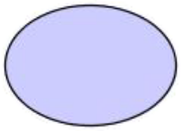 | Regular use case (concrete)
 | Aggregate use case
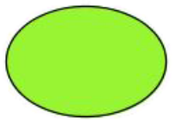 | External use case (not in scope)

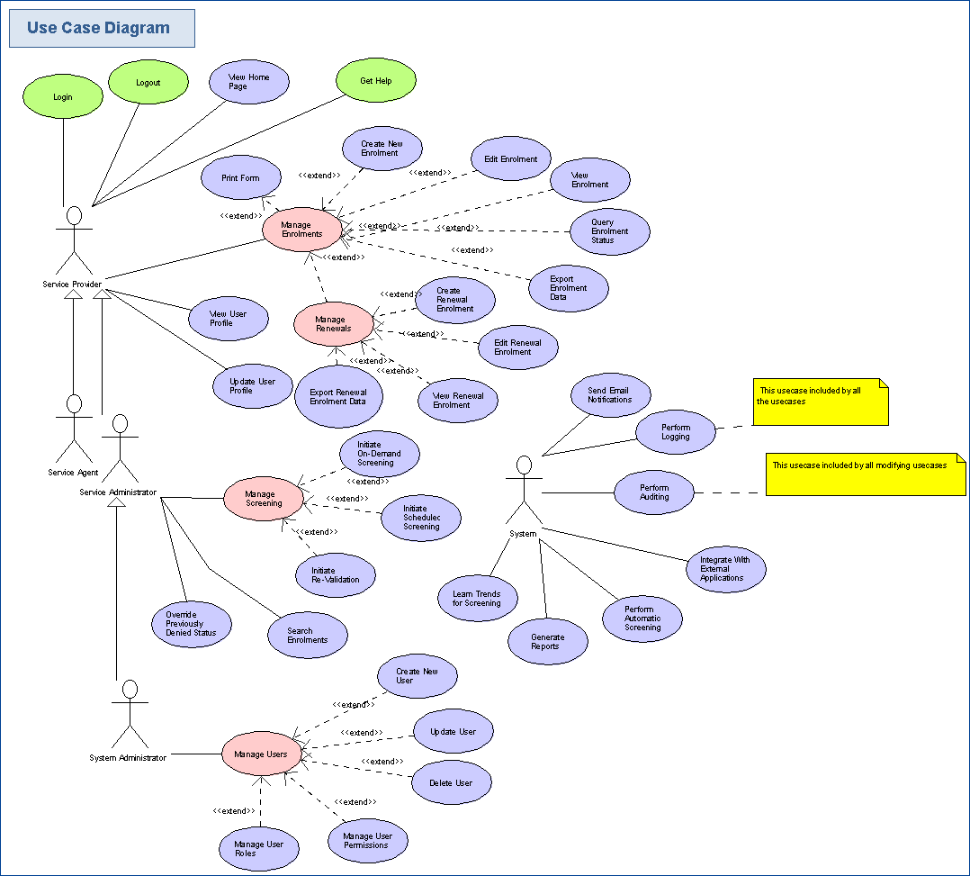

Business Requirements

This section identifies, enumerates and explores the business requirements that must be met by the application. Business requirements include capturing the types of users, the basic inputs and outputs, the system’s dependencies, and the tasks the system should accomplish. Some business requirement for a web-based retail site might include:

Users: “The system supports public browsers, registered members, service administrators, and system administrators.”
Tasks: “Screening will be scheduled for 10 hours,” “enrolment expires in a configurable period, and the default is 365 days”, etc.

It is important to confirm that Task Requirements include all the tasks required to meet the business objectives.

Users

Provider

Provider is medical service provider who is enrolling or already enrolled into the MediCare Health program.

Service Agent
A service agent is a user who assists Providers in completing the claim forms. The Service Agent may have additional administrative features as well.

Service Administrator

A service administrator is a user who has administrative policy rights on the application. This user can edit enroll and screening information.

System Administrator

A system administrator is a user able to manage all other users’ data and role. This user role is able to modify the authenticated users on the system as well as their individual roles.

User Access Levels:

Below is a table provided by the client which outlines the details on each role including which records they should be allowed to access (record visibility), what types of records, actions they can perform on those records, and whether that role will need access to ad-hoc reporting capabilities on the records:

 | Provider | Service Agent | Service Administrator |  | Admin | System
Login | X | X
Logout | X | X
View Homepage | X | X
Get Help | X | X
Create New Enrolment | X | X
Edit Enrolment | X | X
View Enrolment | X | X
Query Enrolment Status | X | X
Search Enrolments | X | X
Edit Renewal Enrolment | X | X
View Renewal Enrolment | X | X
View User Profile | X | X
Update User Profile | X | X
Perform On-Demand Screening |  |  |  |  | X
Perform Scheduled Screening |  |  |  |  | X
Create New User |  |  |  |  | X
Update User | X | X | X |  | X
View User | X | X | X |  | X
Delete User |  |  |  |  | X
Manage User Permissions |  |  |  |  | X
Perform Automatic Screening |  |  | X |  |  | X
Integrate With External Applications |  |  |  |  |  | X
Check for Updates to Program |  |  |  |  |  | X
Perform Logging |  |  |  |  |  | X
Perform Auditing |  |  |  |  |  | X
Send E-mail Notifications |  |  |  |  |  | X

Inputs/Outputs
This section identifies and describes the inputs to and outputs from the new application. Inputs can include electronic inputs, like RSS and EDI feeds, updates from external databases, etc, as well as human inputs, like “user X keys in results from report Y.” Output can include electronic feeds, printed reports, etc. In this section, all electronic inputs and outputs are captured. Human inputs are omitted from this section.

Inputs

User Credentials (Login)
The user credentials are required for the user to log in and gain access to the application.

User Role
The system will use the user role from the client’s existing authentication system to determine authorization level of the user.

Manual Enrolment Creation
The users will enter form fields to create enrolment.

Manual Enrolment Modification
The users will edit the details to modify enrolments.

Search Queries
The user will enter basic and advanced search queries to the application. Sorting and filtering options can be also chosen by the user.

Manual Renewal Creation
The user will enter data to create renewal enrolments details.

Manual Renewal Modification
The users will edit details to modify renewal enrolment details.

Provider Data sent to PVS
The system sends applicable provider data to PVS for data validation.

Provider Data sent to SIRS
The system sends applicable provider data to SIRS for checking provider integrity.

Provider Data sent to NetStudy (Licensing)
The system sends applicable provider data to NetStudy for checking background.

Outputs

Authentication request to Existing Authentication System
The application will send an authentication request to the existing authentication system to have the user authenticated.

Application Screens
Information displayed to users will be output to application screens for the user to view.

Database
The data for all enrolments, renewals, users and user role will be saved to the Oracle Database.

Found Results
The application will display found results (from basic and advanced search) to the user.

Email Notifications
The application will send email notifications to user when specific actions like completion of screening. .

Exported Enrolment
The application will allow users to export enrolment data into convenient output format.

Print Requests (external)
Users will be able to use their web browser print functionality to print pages displayed in the application.

Logging Data
The application will save logging data of all errors, exceptions, and warnings to log records.

Scanner
The application will be able to scan finger prints, forms of any provider.
10/11/2012: Update – This is not required. Instead the service admin will be able to update this in the system using a checkbox provided.

Auditing Data
The application will save all changes made to the database as auditing records. Usage metrics will also be captured with auditing data.

Verification Results of PVS
The PVS sends back the verification results performed on the applicable provider data back to the application.

Integrity Check Results of SIRS
The SIRS sends back the integrity check results performed on the applicable provider data back to the application.

Background Check Results of NetStudy (Licensing)
The NetStudy (Licensing) sends back the background check results performed on the applicable provider data back to the application.

Dependencies
Human inputs are also categorized as dependencies. List all dependencies:

Application Database
The system will save application data into an application database.

Security Service
The application depends on the existing security service to authenticate/authorize users before they can use any of its functionality.

Local File System
The application will be dependent on reading and writing data to and from their local file system (logging / audit files).

Web Server
The application will be installed on a web server so users will be able to access it from anywhere.

Application Server
The application will be installed on an application server for deployment.

Web Browser
Users will access the application through a web browser.

Printer
The application will be able to print reports and any webpage on the printer.

Email Server
The application will be dependent on the email server in order to send out email notifications.

Logging System
The application is dependent on the logging system.

Auditing System
The application is dependent on the auditing system.

SIRS(Surveillance & Integrity Review Section)
This system is used to check the integrity of service provider. It checks site visits before pre/post site visits

PVS
This system is used to Perform Provider Data Verification

Data Validation Service
This system is used to perform Provider Data Validation

Terminated Providers
This system is used to query the cause of the provider termination.

Professional Licensing Board
This system is used to query the Query Provider License Information

MediCare Certified Providers
This system is used to query the medicate provider information.

SSDM
This system has provider’s information on death.

OIG
This system query list of excluded individuals and entities

HHS
This system provider list of excluded providers list

NNPES
This system provider information from National Plan and Provider Enumeration System

Human Dependencies:

Please refer to section 4.1 for details.

Task Requirements
Task Requirements correlate to the use cases, above. There should be at least one task for each use case bubble. Each use case should be briefly described. If there are specific requirements related to the use case, they should also be listed. This section captures high-level, basic functional requirements. Detailed requirements will be defined during the Requirements Specification contests.

User Functionality

NOTE: Some of the functionality below is restricted by user type. Please see section 4.1 for details on user access level.

Log In (external)
- User’s credentials are verified to ensure they are authorized to use functionality of the application.
- Credentials will be authenticated via the existing authentication system.
- The user will get access rights to the application functionality and data according to their user role and enrolments available to them.

Log Out (external)
- When the user is done using the system and close the application they will be logged out from the system.
- The application will also have session timeout functionality to automatically log user out after a specific amount of time inactive.
- After log out, user will not be able to access any of the application functionality until they go back through the log in process.

View Homepage
- This use case is triggered when a user logs into the application and their homepage is displayed.
- The application will display the homepage customized by user type.
  - Views available include:
    - System Admin Views
    - Provider Views
    - Service Agent Views
    - Service Administrator
- A summary of enrolments will be displayed.
- The user has the ability to click on individual enrolment to view it details
- Items that need the user’s attention will be highlighted so it’s easy for the user to notice and be proactive in resolving them.

View Help(in scope for later version of the application)
- This use case is triggered when a user requests help.
- The application will display help content for the user to browse through.
- The user can freely access all the help information about the application usage – like by choosing “Help” menu option or by some button.
- It will be possible to get detailed data on the application features and user interface as well.
- The help can be open only on the user’s request and it will not affect the application performance at all.

Create Enrolment
- This use case allows the user to create a new enrolment by filling form fields.
- Each service provider should enroll only once (with exception of renewal)
- The application will display appropriate form(s) to the providers based on their Provider Type and Enrollment Type
- The user will enter the details for the enrolment they wish to claim for
  - Select Provider Type - Examples are Physician, Dentist, and Nurse Practitioner
- Select Enrollment Type – new or renewal of enrollment(it will be new in this use case)
- The application will allow the providers to enter their EFT information.
- For ‘High Risk’ category the system needs to get the fingerprint status, which the provider gives to the local police department. The service admin will verify this manually and update the system.
- The user will select to create the enrolment when they are done.
- The application will determine whether the provider needs to pay enrolment fee.
  - If yes, the application will prompt the user to enter pay amount credit cards.

- Specifically, the provider will enter the following details for registering new enrolment
  - LAST NAME -
  - FIRST NAME
  - MIDDLE NAME
  - NPI (Type 1 only) – NPI is National Provider Identifier - a unique 10-digit identification number issued to health care providers in the United States by the Centers for Medicare and Medicaid Services (CMS).
(The NPI Registry enables you to search for a provider's NPPES (National Plan & Provider Enumeration System) information. All information produced by the NPI Registry is provided in accordance with the NPPES Data Dissemination Notice. Information in the NPI Registry is updated daily. We may run simple queries to retrieve this read-only data. For example, users may search for a provider by the NPI or Legal Business Name. There is no charge to use the NPI Registry)
For more details please see http://en.wikipedia.org/wiki/National_Provider_Identifier

Type 1 NPI and Type 2 NPI
Type 1 - Health care providers who are individuals, including physicians, radiologists and all sole proprietors. An individual is eligible for only one NPI.
Type 2 - Health care providers that are organizations, including physician groups, hospitals, nursing homes, and the corporations formed when an individual incorporates him/herself.

Please note that NPI (Type 1 only) is mentioned on Individual application because some providers may have a private practice and might have obtained a Type 2 NPI for that practice, so they think they need to provide that on the Application. When an individual is enrolling, we want to make sure they are only using their Type 1 NPI.

  - SOCIAL SECURITY NUMBER (In the United States, a Social Security number (SSN) is a nine-digit number issued to U.S. citizens, permanent residents, and temporary (working) residents under section 205(c)(2) of the Social Security Act, The number is issued to an individual by the Social Security Administration, an independent agency of the United States government. Its primary purpose is to track individuals for Social Security purposes).

  - DATE OF BIRTH
  - REQUESTED EFFECTIVE DATE – The date the applicants want their enrollment to begin. We have to allow a provider to become effective up to 12 months back, but not any earlier than their license and/or certification is effective.
  - HIGHEST DEGREE EARNED - Masters or Doctorate
  - DATE DEGREE AWARDED
  - INDIVIDUAL PRACTITIONER'S EMAIL ADDRESS (if applicable)
  - Type of License/Certification - Some providers are required to have a state license AND a national certification, so that information needs to be included here.
  - License/Certification Number
  - Original Issue Date
  - Renewal End Date
  - Issuing State
  - Individual Practitioner's Specialty - Physician Specialties, Dental Specialties, Nurse Practitioner Specialties, Private Duty Nurse Specialties, Psychology Specialty
  - Individual Practitioner's Specialty Certifications – list of certifications
    - Type of Specialty,
    - Certification Number,
    - Original Issue Date,
    - Renewal End Date,
    - Issuing State
  - Private Practice or Primary Office Location Information – (Some providers work for themselves in a private or solo practice. Those that do not must provide an office location in which they primarily work)
    - Do you maintain your own private practice? – YES/No
    - Are you employed and/or independently contracted by a group practice? - YES/NO
    - PRACTICE NAME (if applicable)
    - GROUP NPI/UMPI (if applicable) – (This should be the NPI/UMPI of the primary office location, if there is one.)
Please note that UMPI refers to “Unique Minnesota Provider Identifier”.
    - LOCATION ADDRESS (Practice location cannot be a PO Box)
    - CITY
    - STATE
    - ZIP CODE
    - COUNTY
    - OFFICE PHONE NUMBER
    - OFFICE FAX NUMBER
    - FEDERAL TAX ID NUMBER (if applicable and you are the owner of the practice) LEGAL NAME ACCORDING TO THE IRS (do not abbreviate) - (Individuals in private practice may have tax information under which they want their payments to be submitted. If they are in private practice, they can tell us that information)
    - MINNESOTA TAX ID (if applicable and you are the owner of the practice) FISCAL YEAR END (default is 12/31)
- (Individuals in private practice may have tax information under which they want their payments to be submitted. If they are in private practice, they can tell us that information).

  - Alternate Mailing Addresses
    - ATTN
    - ADDRESS
    - CITY
    - STATE
    - ZIP CODE
Remittance Advice - Address1/Address2/Address3
Reimbursement Check - Address1/Address2/Address3
Provider Correspondence - Address1/Address2/Address3
Authorization Request Notice and Service Agreements- Address1/Address2/Address3
Credentials (Enrollment Status) - Address1/Address2/Address3

  - Remittance Sequence – (Providers receive a Remittance Advice report twice a month detailing their claims. This option allows the provider to tell us in which order the claims should appear on the report)
    - Patient Account or Own Reference Number Order
    - DHS Transaction Control Number Order
    - Recipient MHCP ID Number Order

  - Group Affiliation Information – (If the provider is working for enrolled organizations, they can provide that information here)
    - GROUP NAME
    - GROUP
    - NPI/UMPI (UMPI refers to Unique Minnesota Provider Identifier)
    - PRACTICE LOCATION
    - ADDRESS
    - CITY
    - STATE
    - ZIP CODE
  - Disqualification Information
    - Have you ever been convicted of a criminal offense related to involvement in any program under Medicare, Medicaid, Title XX, or Title XXI in Minnesota or any other state or jurisdiction since the inception of these programs? Yes/No,
    - Have you had civil money penalties or assessments imposed under section 1128A of the Social Security Act? Yes/No
    - Have you ever been excluded or terminated from participation in Medicare, Medicaid, Children’s Health Insurance Program (CHIP), or the Title XXI services program in Minnesota or any other state since the inception of these programs? YES/NO

  - Contact Information
    - CREDENTIALING CONTACT
    - NAME
    - PHONE NUMBER
    - FAX NUMBER
    - EMAIL ADDRESS
  - Provider Statement
    - PROVIDER NAME
    - TITLE
    - DATE
- The application will save details for the new enrolment to the application database.
- The application automatically creates the provider profile on successful acceptance of enrolment request.

Edit Enrolment
- This use case allows the user to edit an unapproved or yet to be approved enrolment
- The application will display the current enrolment details in editable data fields.
- The user will edit the details for the enrolment they wish to change.
- The user will select to save the edits when they are done.
- The editable fields are:
  - LAST NAME -
  - FIRST NAME
  - MIDDLE NAME
  - NPI (Type 1 only) – NPI is National Provider Identifier - a unique 10-digit identification number issued to health care providers in the United States by the Centers for Medicare and Medicaid Services (CMS).
(The NPI Registry enables you to search for a provider's NPPES (National Plan & Provider Enumeration System) information. All information produced by the NPI Registry is provided in accordance with the NPPES Data Dissemination Notice. Information in the NPI Registry is updated daily. We may run simple queries to retrieve this read-only data. For example, users may search for a provider by the NPI or Legal Business Name. There is no charge to use the NPI Registry)
For more details please see http://en.wikipedia.org/wiki/National_Provider_Identifier

Type 1 NPI and Type 2 NPI
Type 1 - Health care providers who are individuals, including physicians, radiologists and all sole proprietors. An individual is eligible for only one NPI.
Type 2 - Health care providers that are organizations, including physician groups, hospitals, nursing homes, and the corporations formed when an individual incorporates him/herself.

Please note that NPI (Type 1 only) is mentioned on Individual application because some providers may have a private practice and might have obtained a Type 2 NPI for that practice, so they think they need to provide that on the Application. When an individual is enrolling, we want to make sure they are only using their Type 1 NPI.

  - SOCIAL SECURITY NUMBER (In the United States, a Social Security number (SSN) is a nine-digit number issued to U.S. citizens, permanent residents, and temporary (working) residents under section 205(c)(2) of the Social Security Act, The number is issued to an individual by the Social Security Administration, an independent agency of the United States government. Its primary purpose is to track individuals for Social Security purposes).

  - DATE OF BIRTH
  - REQUESTED EFFECTIVE DATE – The date the applicants want their enrollment to begin. We have to allow a provider to become effective up to 12 months back, but not any earlier than their license and/or certification is effective.
  - HIGHEST DEGREE EARNED - Masters or Doctorate
  - DATE DEGREE AWARDED
  - INDIVIDUAL PRACTITIONER'S EMAIL ADDRESS (if applicable)
  - Type of License/Certification - Some providers are required to have a state license AND a national certification, so that information needs to be included here.
  - License/Certification Number
  - Original Issue Date
  - Renewal End Date
  - Issuing State
  - Individual Practitioner's Specialty - Physician Specialties, Dental Specialties, Nurse Practitioner Specialties, Private Duty Nurse Specialties, Psychology Specialty
  - Individual Practitioner's Specialty Certifications – list of certifications
    - Type of Specialty,
    - Certification Number,
    - Original Issue Date,
    - Renewal End Date,
    - Issuing State
  - Private Practice or Primary Office Location Information – (Some providers work for themselves in a private or solo practice. Those that do not must provide an office location in which they primarily work)
    - Do you maintain your own private practice? – YES/No
    - Are you employed and/or independently contracted by a group practice? - YES/NO
    - PRACTICE NAME (if applicable)
    - GROUP NPI/UMPI (if applicable) – (This should be the NPI/UMPI of the primary office location, if there is one.)
Please note that UMPI refers to “Unique Minnesota Provider Identifier”.
    - LOCATION ADDRESS (Practice location cannot be a PO Box)
    - CITY
    - STATE
    - ZIP CODE
    - COUNTY
    - OFFICE PHONE NUMBER
    - OFFICE FAX NUMBER
    - FEDERAL TAX ID NUMBER (if applicable and you are the owner of the practice) LEGAL NAME ACCORDING TO THE IRS (do not abbreviate) - (Individuals in private practice may have tax information under which they want their payments to be submitted. If they are in private practice, they can tell us that information)
    - MINNESOTA TAX ID (if applicable and you are the owner of the practice) FISCAL YEAR END (default is 12/31)
- (Individuals in private practice may have tax information under which they want their payments to be submitted. If they are in private practice, they can tell us that information).

  - Alternate Mailing Addresses
    - ATTN
    - ADDRESS
    - CITY
    - STATE
    - ZIP CODE
Remittance Advice - Address1/Address2/Address3
Reimbursement Check - Address1/Address2/Address3
Provider Correspondence - Address1/Address2/Address3
Authorization Request Notice and Service Agreements- Address1/Address2/Address3
Credentials (Enrollment Status) - Address1/Address2/Address3

  - Remittance Sequence – (Providers receive a Remittance Advice report twice a month detailing their claims. This option allows the provider to tell us in which order the claims should appear on the report)
    - Patient Account or Own Reference Number Order
    - DHS Transaction Control Number Order
    - Recipient MHCP ID Number Order

  - Group Affiliation Information – (If the provider is working for enrolled organizations, they can provide that information here)
    - GROUP NAME
    - GROUP
    - NPI/UMPI (UMPI refers to Unique Minnesota Provider Identifier)
    - PRACTICE LOCATION
    - ADDRESS
    - CITY
    - STATE
    - ZIP CODE
  - Disqualification Information
    - Have you ever been convicted of a criminal offense related to involvement in any program under Medicare, Medicaid, Title XX, or Title XXI in Minnesota or any other state or jurisdiction since the inception of these programs? Yes/No,
    - Have you had civil money penalties or assessments imposed under section 1128A of the Social Security Act? Yes/No
    - Have you ever been excluded or terminated from participation in Medicare, Medicaid, Children’s Health Insurance Program (CHIP), or the Title XXI services program in Minnesota or any other state since the inception of these programs? YES/NO

  - Contact Information
    - CREDENTIALING CONTACT
    - NAME
    - PHONE NUMBER
    - FAX NUMBER
    - EMAIL ADDRESS
  - Provider Statement
    - PROVIDER NAME
    - TITLE
    - DATE
- The application will save the edited details for the enrolment to the application database.

View Enrolment
- This use case allows the user to view the details for a single renewal enrolment they have selected.
- The application will display details for the individual enrolment.
- The use case will display the following information.
  - LAST NAME -
  - FIRST NAME
  - MIDDLE NAME
  - NPI (Type 1 only) – NPI is National Provider Identifier - a unique 10-digit identification number issued to health care providers in the United States by the Centers for Medicare and Medicaid Services (CMS).
(The NPI Registry enables you to search for a provider's NPPES (National Plan & Provider Enumeration System) information. All information produced by the NPI Registry is provided in accordance with the NPPES Data Dissemination Notice. Information in the NPI Registry is updated daily. We may run simple queries to retrieve this read-only data. For example, users may search for a provider by the NPI or Legal Business Name. There is no charge to use the NPI Registry)
For more details please see http://en.wikipedia.org/wiki/National_Provider_Identifier

Type 1 NPI and Type 2 NPI
Type 1 - Health care providers who are individuals, including physicians, radiologists and all sole proprietors. An individual is eligible for only one NPI.
Type 2 - Health care providers that are organizations, including physician groups, hospitals, nursing homes, and the corporations formed when an individual incorporates him/herself.

Please note that NPI (Type 1 only) is mentioned on Individual application because some providers may have a private practice and might have obtained a Type 2 NPI for that practice, so they think they need to provide that on the Application. When an individual is enrolling, we want to make sure they are only using their Type 1 NPI.

  - SOCIAL SECURITY NUMBER (In the United States, a Social Security number (SSN) is a nine-digit number issued to U.S. citizens, permanent residents, and temporary (working) residents under section 205(c)(2) of the Social Security Act, The number is issued to an individual by the Social Security Administration, an independent agency of the United States government. Its primary purpose is to track individuals for Social Security purposes).

  - DATE OF BIRTH
  - REQUESTED EFFECTIVE DATE – The date the applicants want their enrollment to begin. We have to allow a provider to become effective up to 12 months back, but not any earlier than their license and/or certification is effective.
  - HIGHEST DEGREE EARNED - Masters or Doctorate
  - DATE DEGREE AWARDED
  - INDIVIDUAL PRACTITIONER'S EMAIL ADDRESS (if applicable)
  - Type of License/Certification - Some providers are required to have a state license AND a national certification, so that information needs to be included here.
  - License/Certification Number
  - Original Issue Date
  - Renewal End Date
  - Issuing State
  - Individual Practitioner's Specialty - Physician Specialties, Dental Specialties, Nurse Practitioner Specialties, Private Duty Nurse Specialties, Psychology Specialty
  - Individual Practitioner's Specialty Certifications – list of certifications
    - Type of Specialty,
    - Certification Number,
    - Original Issue Date,
    - Renewal End Date,
    - Issuing State
  - Private Practice or Primary Office Location Information – (Some providers work for themselves in a private or solo practice. Those that do not must provide an office location in which they primarily work)
    - Do you maintain your own private practice? – YES/No
    - Are you employed and/or independently contracted by a group practice? - YES/NO
    - PRACTICE NAME (if applicable)
    - GROUP NPI/UMPI (if applicable) – (This should be the NPI/UMPI of the primary office location, if there is one.)
Please note that UMPI refers to “Unique Minnesota Provider Identifier”.
    - LOCATION ADDRESS (Practice location cannot be a PO Box)
    - CITY
    - STATE
    - ZIP CODE
    - COUNTY
    - OFFICE PHONE NUMBER
    - OFFICE FAX NUMBER
    - FEDERAL TAX ID NUMBER (if applicable and you are the owner of the practice) LEGAL NAME ACCORDING TO THE IRS (do not abbreviate) - (Individuals in private practice may have tax information under which they want their payments to be submitted. If they are in private practice, they can tell us that information)
    - MINNESOTA TAX ID (if applicable and you are the owner of the practice) FISCAL YEAR END (default is 12/31)
- (Individuals in private practice may have tax information under which they want their payments to be submitted. If they are in private practice, they can tell us that information).

  - Alternate Mailing Addresses
    - ATTN
    - ADDRESS
    - CITY
    - STATE
    - ZIP CODE
Remittance Advice - Address1/Address2/Address3
Reimbursement Check - Address1/Address2/Address3
Provider Correspondence - Address1/Address2/Address3
Authorization Request Notice and Service Agreements- Address1/Address2/Address3
Credentials (Enrollment Status) - Address1/Address2/Address3

  - Remittance Sequence – (Providers receive a Remittance Advice report twice a month detailing their claims. This option allows the provider to tell us in which order the claims should appear on the report)
    - Patient Account or Own Reference Number Order
    - DHS Transaction Control Number Order
    - Recipient MHCP ID Number Order

  - Group Affiliation Information – (If the provider is working for enrolled organizations, they can provide that information here)
    - GROUP NAME
    - GROUP
    - NPI/UMPI (UMPI refers to Unique Minnesota Provider Identifier)
    - PRACTICE LOCATION
    - ADDRESS
    - CITY
    - STATE
    - ZIP CODE
  - Disqualification Information
    - Have you ever been convicted of a criminal offense related to involvement in any program under Medicare, Medicaid, Title XX, or Title XXI in Minnesota or any other state or jurisdiction since the inception of these programs? Yes/No,
    - Have you had civil money penalties or assessments imposed under section 1128A of the Social Security Act? Yes/No
    - Have you ever been excluded or terminated from participation in Medicare, Medicaid, Children’s Health Insurance Program (CHIP), or the Title XXI services program in Minnesota or any other state since the inception of these programs? YES/NO

  - Contact Information
    - CREDENTIALING CONTACT
    - NAME
    - PHONE NUMBER
    - FAX NUMBER
    - EMAIL ADDRESS
  - Provider Statement
    - PROVIDER NAME
    - TITLE
    - DATE

Query Enrolment Status
- This use case allows a user to query the status of an existing enrolment after submitting their completed application forms.
- The users must be logged in to the application to access their enrollment status.
- The user will enter the enrolment number they wish to know the status
- The user will submit the query to retrieve it from DB when they are done.
- The application will display status details for the individual enrolment.
- Possible status values of enrolment are:
  - “ Processing”,
  - “Accepted”
  - “Rejected”.
  - “Expired”

Export Enrolment Data
- Once enrolment form is submit, the user will have the option to select it to target PDF file.
- The users must be logged in to export their enrolment data.
- The user will select the filename for their exported report and the location they wish the exported report to be saved to.
- The Architect needs to choose an efficient library for exporting data to PDF.

Create Renewal
- This use case allows the user to create a renewal enrolment by filling form fields.
- The application will display appropriate form(s) to the providers based on their Provider Type and renewal enrollment Type
- The user will enter the details for the enrolment they wish to claim for
  - Select Provider Type - Examples are Physician, Dentist, and Nurse Practitioner
- Select Enrollment Type – new or renewal of enrollment(it will be renewal in this use case)
- For ‘High Risk’ category the system needs to get the fingerprint status, which the provider gives to the local police station. The service admin will verify this manually and update the system.
- The user will select to create the enrolment when they are done.
- The application will determine whether the provider needs to pay enrolment fee.
  - If yes, the application will prompt the user to enter pay amount credit cards
- Specifically, the provider can enter the following details for registering renewal enrolment:
  - LAST NAME - denotes the provider last name
  - FIRST NAME - denotes the provider first name
  - MIDDLE NAME – denotes the provider middle name
(Please note that a provider's name may change, and if it changes, then it will trigger a re-screening)
  - REQUESTED EFFECTIVE DATE – The date the applicants want their enrollment to begin. We have to allow a provider to become effective up to 12 months back, but not any earlier than their license and/or certification is effective.
  - INDIVIDUAL PRACTITIONER'S EMAIL ADDRESS (if applicable) – denotes the individual practitioners email address.
  - Private Practice or Primary Office Location Information - (Some providers work for themselves in a private or solo practice. Those that do not must provide an office location in which they primarily work)
    - Do you maintain your own private practice? – YES/No
    - Are you employed and/or independently contracted by a group practice? - YES/NO
    - PRACTICE NAME (if applicable) - denotes the practice name
    - GROUP NPI/UMPI (if applicable) - (This should be the NPI/UMPI of the primary office location, if there is one.)
Please note that UMPI refers to “Unique Minnesota Provider Identifier”.
    - LOCATION ADDRESS (Practice location cannot be a PO Box) – denotes the practice address.
    - CITY – denotes practice city
    - STATE – denotes the practice state
    - ZIP CODE - denotes the practice zip code
    - COUNTY – denotes the practice country code.
    - OFFICE PHONE NUMBER - denotes the office phone number
    - OFFICE FAX NUMBER – denotes the office fax number
    - FEDERAL TAX ID NUMBER (if applicable and you are the owner of the practice) LEGAL NAME ACCORDING TO THE IRS (do not abbreviate) – (Individuals in private practice may have tax information under which they want their payments to be submitted. If they are in private practice, they can tell us that information)
    - MINNESOTA TAX ID (if applicable and you are the owner of the practice) FISCAL YEAR END (default is 12/31) – denotes the Minnesota tax id. - (Individuals in private practice may have tax information under which they want their payments to be submitted. If they are in private practice, they can tell us that information).
  - Alternate Mailing Addresses
    - ATTN – denotes the alternative number
    - ADDRESS – denotes the alternative mailing address.
    - CITY – denotes the alternative mailing city
    - STATE – denotes the alternative mailing state
    - ZIP CODE – denotes the alternative mailing zip code
Remittance Advice - Address1/Address2/Address3
Reimbursement Check - Address1/Address2/Address3
Provider Correspondence - Address1/Address2/Address3
Authorization Request Notice and Service Agreements- Address1/Address2/Address3
Credentials (Enrollment Status) - Address1/Address2/Address3

  - Remittance Sequence - (Providers receive a Remittance Advice report twice a month detailing their claims. This option allows the provider to tell us in which order the claims should appear on the report)
    - Patient Account or Own Reference Number Order
    - DHS Transaction Control Number Order
    - Recipient MHCP ID Number Order

  - Group Affiliation Information - (If the provider is working for enrolled organizations, they can provide that information here)
    - GROUP NAME - denotes the group affiliation name
    - GROUP – denotes the affiliation group
    - NPI/UMPI – denotes NPI, (UMPI refers to Unique Minnesota Provider Identifier)
    - PRACTICE LOCATION – denotes the practice location
    - ADDRESS – denotes the affiliation address.
    - CITY – denotes the affiliation city
    - STATE - denotes the affiliation state
    - ZIP CODE – denotes the affiliation zip code.

  - Contact Information
    - CREDENTIALING CONTACT – denotes the contact credentials
    - NAME – denotes the contact name
    - PHONE NUMBER – denotes the contact phone number.
    - FAX NUMBER – denotes the contact fax number
    - EMAIL ADDRESS – denotes the contact email address.
  - Provider Statement
    - DATE – denotes the provider statement date.
- The application will save details for the renewal enrolment to the application database.

Edit Renewal
- This use case allows the user to edit an unapproved or yet to be approved renewal enrolment
- The application will display the current renewal enrolment details in editable data fields
- The user will edit the details for the renewal enrolment they wish to change.
- The user will select to save the edits when they are done.
- The editable fields are:
  - LAST NAME - denotes the provider last name
  - FIRST NAME - denotes the provider first name
  - MIDDLE NAME – denotes the provider middle name
(Please note that a provider's name may change, and if it changes, then it will trigger a re-screening)
  - REQUESTED EFFECTIVE DATE – The date the applicants want their enrollment to begin. We have to allow a provider to become effective up to 12 months back, but not any earlier than their license and/or certification is effective.
  - INDIVIDUAL PRACTITIONER'S EMAIL ADDRESS (if applicable) – denotes the individual practitioners email address.
  - Private Practice or Primary Office Location Information - (Some providers work for themselves in a private or solo practice. Those that do not must provide an office location in which they primarily work)
    - Do you maintain your own private practice? – YES/No
    - Are you employed and/or independently contracted by a group practice? - YES/NO
    - PRACTICE NAME (if applicable) - denotes the practice name
    - GROUP NPI/UMPI (if applicable) - (This should be the NPI/UMPI of the primary office location, if there is one.)
Please note that UMPI refers to “Unique Minnesota Provider Identifier”.
    - LOCATION ADDRESS (Practice location cannot be a PO Box) – denotes the practice address.
    - CITY – denotes practice city
    - STATE – denotes the practice state
    - ZIP CODE - denotes the practice zip code
    - COUNTY – denotes the practice country code.
    - OFFICE PHONE NUMBER - denotes the office phone number
    - OFFICE FAX NUMBER – denotes the office fax number
    - FEDERAL TAX ID NUMBER (if applicable and you are the owner of the practice) LEGAL NAME ACCORDING TO THE IRS (do not abbreviate) – (Individuals in private practice may have tax information under which they want their payments to be submitted. If they are in private practice, they can tell us that information)
    - MINNESOTA TAX ID (if applicable and you are the owner of the practice) FISCAL YEAR END (default is 12/31) – denotes the Minnesota tax id. - (Individuals in private practice may have tax information under which they want their payments to be submitted. If they are in private practice, they can tell us that information).
  - Alternate Mailing Addresses
    - ATTN – denotes the alternative number
    - ADDRESS – denotes the alternative mailing address.
    - CITY – denotes the alternative mailing city
    - STATE – denotes the alternative mailing state
    - ZIP CODE – denotes the alternative mailing zip code
Remittance Advice - Address1/Address2/Address3
Reimbursement Check - Address1/Address2/Address3
Provider Correspondence - Address1/Address2/Address3
Authorization Request Notice and Service Agreements- Address1/Address2/Address3
Credentials (Enrollment Status) - Address1/Address2/Address3

  - Remittance Sequence - (Providers receive a Remittance Advice report twice a month detailing their claims. This option allows the provider to tell us in which order the claims should appear on the report)
    - Patient Account or Own Reference Number Order
    - DHS Transaction Control Number Order
    - Recipient MHCP ID Number Order

  - Group Affiliation Information - (If the provider is working for enrolled organizations, they can provide that information here)
    - GROUP NAME - denotes the group affiliation name
    - GROUP – denotes the affiliation group
    - NPI/UMPI – denotes NPI, (UMPI refers to Unique Minnesota Provider Identifier)
    - PRACTICE LOCATION – denotes the practice location
    - ADDRESS – denotes the affiliation address.
    - CITY – denotes the affiliation city
    - STATE - denotes the affiliation state
    - ZIP CODE – denotes the affiliation zip code.

  - Contact Information
    - CREDENTIALING CONTACT – denotes the contact credentials
    - NAME – denotes the contact name
    - PHONE NUMBER – denotes the contact phone number.
    - FAX NUMBER – denotes the contact fax number
    - EMAIL ADDRESS – denotes the contact email address.
  - Provider Statement
    - DATE – denotes the provider statement date.
- The application will save the edited details for the enrolment to the application database.

View Renewal Enrolment
- This use case allows the user to view the details for a single enrolment they have selected.
- The application will display details for the individual enrolment.
- The use case will display the following information.
  - LAST NAME -
  - FIRST NAME
  - MIDDLE NAME
  - NPI (Type 1 only) – NPI is National Provider Identifier - a unique 10-digit identification number issued to health care providers in the United States by the Centers for Medicare and Medicaid Services (CMS).
(The NPI Registry enables you to search for a provider's NPPES (National Plan & Provider Enumeration System) information. All information produced by the NPI Registry is provided in accordance with the NPPES Data Dissemination Notice. Information in the NPI Registry is updated daily. We may run simple queries to retrieve this read-only data. For example, users may search for a provider by the NPI or Legal Business Name. There is no charge to use the NPI Registry)
For more details please see http://en.wikipedia.org/wiki/National_Provider_Identifier

Type 1 NPI and Type 2 NPI
Type 1 - Health care providers who are individuals, including physicians, radiologists and all sole proprietors. An individual is eligible for only one NPI.
Type 2 - Health care providers that are organizations, including physician groups, hospitals, nursing homes, and the corporations formed when an individual incorporates him/herself.

Please note that NPI (Type 1 only) is mentioned on Individual application because some providers may have a private practice and might have obtained a Type 2 NPI for that practice, so they think they need to provide that on the Application. When an individual is enrolling, we want to make sure they are only using their Type 1 NPI.

  - SOCIAL SECURITY NUMBER (In the United States, a Social Security number (SSN) is a nine-digit number issued to U.S. citizens, permanent residents, and temporary (working) residents under section 205(c)(2) of the Social Security Act, The number is issued to an individual by the Social Security Administration, an independent agency of the United States government. Its primary purpose is to track individuals for Social Security purposes).

  - DATE OF BIRTH
  - REQUESTED EFFECTIVE DATE – The date the applicants want their enrollment to begin. We have to allow a provider to become effective up to 12 months back, but not any earlier than their license and/or certification is effective.
  - HIGHEST DEGREE EARNED - Masters or Doctorate
  - DATE DEGREE AWARDED
  - INDIVIDUAL PRACTITIONER'S EMAIL ADDRESS (if applicable)
  - Type of License/Certification - Some providers are required to have a state license AND a national certification, so that information needs to be included here.
  - License/Certification Number
  - Original Issue Date
  - Renewal End Date
  - Issuing State
  - Individual Practitioner's Specialty - Physician Specialties, Dental Specialties, Nurse Practitioner Specialties, Private Duty Nurse Specialties, Psychology Specialty
  - Individual Practitioner's Specialty Certifications – list of certifications
    - Type of Specialty,
    - Certification Number,
    - Original Issue Date,
    - Renewal End Date,
    - Issuing State
  - Private Practice or Primary Office Location Information – (Some providers work for themselves in a private or solo practice. Those that do not must provide an office location in which they primarily work)
    - Do you maintain your own private practice? – YES/No
    - Are you employed and/or independently contracted by a group practice? - YES/NO
    - PRACTICE NAME (if applicable)
    - GROUP NPI/UMPI (if applicable) – (This should be the NPI/UMPI of the primary office location, if there is one.)
Please note that UMPI refers to “Unique Minnesota Provider Identifier”.
    - LOCATION ADDRESS (Practice location cannot be a PO Box)
    - CITY
    - STATE
    - ZIP CODE
    - COUNTY
    - OFFICE PHONE NUMBER
    - OFFICE FAX NUMBER
    - FEDERAL TAX ID NUMBER (if applicable and you are the owner of the practice) LEGAL NAME ACCORDING TO THE IRS (do not abbreviate) - (Individuals in private practice may have tax information under which they want their payments to be submitted. If they are in private practice, they can tell us that information)
    - MINNESOTA TAX ID (if applicable and you are the owner of the practice) FISCAL YEAR END (default is 12/31)
- (Individuals in private practice may have tax information under which they want their payments to be submitted. If they are in private practice, they can tell us that information).

  - Alternate Mailing Addresses
    - ATTN
    - ADDRESS
    - CITY
    - STATE
    - ZIP CODE
Remittance Advice - Address1/Address2/Address3
Reimbursement Check - Address1/Address2/Address3
Provider Correspondence - Address1/Address2/Address3
Authorization Request Notice and Service Agreements- Address1/Address2/Address3
Credentials (Enrollment Status) - Address1/Address2/Address3

  - Remittance Sequence – (Providers receive a Remittance Advice report twice a month detailing their claims. This option allows the provider to tell us in which order the claims should appear on the report)
    - Patient Account or Own Reference Number Order
    - DHS Transaction Control Number Order
    - Recipient MHCP ID Number Order

  - Group Affiliation Information – (If the provider is working for enrolled organizations, they can provide that information here)
    - GROUP NAME
    - GROUP
    - NPI/UMPI (UMPI refers to Unique Minnesota Provider Identifier)
    - PRACTICE LOCATION
    - ADDRESS
    - CITY
    - STATE
    - ZIP CODE
  - Disqualification Information
    - Have you ever been convicted of a criminal offense related to involvement in any program under Medicare, Medicaid, Title XX, or Title XXI in Minnesota or any other state or jurisdiction since the inception of these programs? Yes/No,
    - Have you had civil money penalties or assessments imposed under section 1128A of the Social Security Act? Yes/No
    - Have you ever been excluded or terminated from participation in Medicare, Medicaid, Children’s Health Insurance Program (CHIP), or the Title XXI services program in Minnesota or any other state since the inception of these programs? YES/NO

  - Contact Information
    - CREDENTIALING CONTACT
    - NAME
    - PHONE NUMBER
    - FAX NUMBER
    - EMAIL ADDRESS
  - Provider Statement
    - PROVIDER NAME
    - TITLE
    - DATE

Export Renewal Enrolment Data
- Once renewal form is submit, the user will have the option to select it to target PDF file.
- The user will select the filename for their exported report and the location they wish the exported report to be saved to.
- The users must be logged in to export their renewal data.
- The user will select the filename for their exported renewal and the location they wish the renewal report to be saved to.
- The Architect needs to choose an efficient library for exporting data to PDF.

View User Profile
- This use case allows the user to view his/her profile information
- The application will display details of the user in paged form.
  - LAST NAME
  - FIRST NAME
  - MIDDLE NAME
  - NPI (Type 1 only)
NPI is National Provider Identifier - a unique 10-digit identification number issued to health care providers in the United States by the Centers for Medicare and Medicaid Services (CMS).
(The NPI Registry enables you to search for a provider's NPPES (National Plan & Provider Enumeration System) information. All information produced by the NPI Registry is provided in accordance with the NPPES Data Dissemination Notice. Information in the NPI Registry is updated daily. We may run simple queries to retrieve this read-only data. For example, users may search for a provider by the NPI or Legal Business Name. There is no charge to use the NPI Registry)
For more details please see: http://en.wikipedia.org/wiki/National_Provider_Identifier

Type 1 NPI and Type 2 NPI
Type 1 - Health care providers who are individuals, including physicians, radiologists and all sole proprietors. An individual is eligible for only one NPI.
Type 2 - Health care providers that are organizations, including physician groups, hospitals, nursing homes, and the corporations formed when an individual incorporates him/herself.

Please note that NPI (Type 1 only) is mentioned on Individual application because some providers may have a private practice and might have obtained a Type 2 NPI for that practice, so they think they need to provide that on the Application. When an individual is enrolling, we want to make sure they are only using their Type 1 NPI.

  - SOCIAL SECURITY NUMBER ((In the United States, a Social Security number (SSN) is a nine-digit number issued to U.S. citizens, permanent residents, and temporary (working) residents under section 205(c)(2) of the Social Security Act, The number is issued to an individual by the Social Security Administration, an independent agency of the United States government. Its primary purpose is to track individuals for Social Security purposes).
  - DATE OF BIRTH
  - REQUESTED EFFECTIVE DATE - The date the applicants want their enrollment to begin. We have to allow a provider to become effective up to 12 months back, but not any earlier than their license and/or certification is effective.
  - HIGHEST DEGREE EARNED - Masters or Doctorate
  - DATE DEGREE AWARDED

Update User Profile
- This use case allows the user to edit his/her profile details.
- The user can edit the following details in the profile:
  - LAST NAME
  - FIRST NAME
  - MIDDLE NAME
  - NPI (Type 1 only)
NPI is National Provider Identifier - a unique 10-digit identification number issued to health care providers in the United States by the Centers for Medicare and Medicaid Services (CMS).
(The NPI Registry enables you to search for a provider's NPPES (National Plan & Provider Enumeration System) information. All information produced by the NPI Registry is provided in accordance with the NPPES Data Dissemination Notice. Information in the NPI Registry is updated daily. We may run simple queries to retrieve this read-only data. For example, users may search for a provider by the NPI or Legal Business Name. There is no charge to use the NPI Registry)
For more details please see: http://en.wikipedia.org/wiki/National_Provider_Identifier

Type 1 NPI and Type 2 NPI
Type 1 - Health care providers who are individuals, including physicians, radiologists and all sole proprietors. An individual is eligible for only one NPI.
Type 2 - Health care providers that are organizations, including physician groups, hospitals, nursing homes, and the corporations formed when an individual incorporates him/herself.

Please note that NPI (Type 1 only) is mentioned on Individual application because some providers may have a private practice and might have obtained a Type 2 NPI for that practice, so they think they need to provide that on the Application. When an individual is enrolling, we want to make sure they are only using their Type 1 NPI.

  - SOCIAL SECURITY NUMBER ((In the United States, a Social Security number (SSN) is a nine-digit number issued to U.S. citizens, permanent residents, and temporary (working) residents under section 205(c)(2) of the Social Security Act, The number is issued to an individual by the Social Security Administration, an independent agency of the United States government. Its primary purpose is to track individuals for Social Security purposes).
  - DATE OF BIRTH
  - REQUESTED EFFECTIVE DATE - The date the applicants want their enrollment to begin. We have to allow a provider to become effective up to 12 months back, but not any earlier than their license and/or certification is effective.
  - HIGHEST DEGREE EARNED - Masters or Doctorate
  - DATE DEGREE AWARDED

Print Form
- This use case allows the user to print form(s).
- The user will be able to print a completed and submitted application form; the form can be either a new enrolment or renewal form.
- The users will take print for their own personal record purpose.

Service Administrator Functionality

Search Enrolments
- The user can select to search for specific enrolments using basic search functionality
- The user can customize the search criteria used
  - User provides a string of alphanumeric characters as input for the application to search for
  - The user also selects the field to search for the input they entered
- The application will run a search based on the user’s search request and display the search results
  - Search results are constrained by the user role and access levels to data
- The user can sort the search results by column (ascending/descending)
- The search results can also be filtered by the user

Set Enrolment Status
- This use case allows a service administrator to set the status of an existing enrolment after submitting their completed application forms.
- The users must be logged in as service administrator/system administrator to set enrollment status.
- The user will enter the enrolment number they wish to change the status
- The user will submit the status changes to DB when they are done.
- .Possible status values of enrolment are:
  - “ Processing”,
  - “Accepted”
  - “Rejected”.

Override Previously Denied Status
- This use case allows a service administrator to override the previously denied applicant status.
- This feature is required because an applicant can appeal a denial.
- The user can search for previously denied applicants, select the particular applicant needed and view the enrollment details and override the status as needed.

Initiate On-Demand Screening
- The new application will able to do screening when ever required.
- The service Administrator normally can trigger the system to perform does when any MediCare Program data changes, when a bunch of enrolment data edited by Service Administrator.

Initiate Scheduled Screening
- The new application will able to do screening of sanction and license boards on through a scheduled verification process.
- The scheduled verification process can be scheduled when ever required by service administrator.
- The Service Administrator can set scheduled verification process for any period.
- The new application will need to interface with external license database to perform screening.
- By default, the application will perform screening at predefined interval period of month.

Initiate Re-Validation
- The system can also be explicitly requested by users to perform re-validation when required.
- The system can be scheduled by the user to perform re-validation.
- The revalidation process will be based on the screening rules.

System Administrator Functionality

View Users
- The System Administrator can view the list of all users.
- The System Administrator can select a particular user and view details.

Create User
- The System Administrator can view all users in the application.
- The System Administrator can create a new user account
- The account details are as followed::
  - User name,
  - Password (shown in stars),
  - E-mail Address,
  - LAST NAME -
  - FIRST NAME
  - MIDDLE NAME
  - User Role,
  - Privileges.

Update User
- The System Administrator can view all users in the application.
- The System Administrator can update any user account
- The details that can be updated are as follows ::
  - User Role,
  - Privileges.

Delete User
- The System Administrator can delete a user from the application.
- The application will set the status of the user to “deleted”

View Roles
- The System Administrator can view all user roles.
- The role details are as follows:
  - User Role name,
  - Privileges.

Create Role
- The System Administrator can create new user roles.
- The role details are as follows:
  - User Role name,
  - Privileges.

Update Role
- The System Administrator can update user roles.
- The role details that can be updated are as follows:
  - User Role name,
  - Privileges.

Delete Role
- The System Administrator can delete user roles.

Manage User Permissions
- There are several predefined (i.e. unchangeable) user roles in the application: Provider, Service Administrator, Service Agent
- The System Administrator can manage user permissions like :
  - View
  - Read
  - Write and
  - Execute permissions.

System Functionality

Send Email Notifications
- This use case is automatically triggered by the system when certain user actions occur (enrolment is denied).
- Notifications will be sent to the user whose attention is required like
  - Service admin will receive notification when user submits updated profile.
  - Provider will get notification when his/her enrolment has approved/denied.
  - Service admin will receive notification when enrolment form is submitted for review.
- The system will send an email notification to the user notifying them of the action that occurred and the next step required by them.
- Mailbox for Minnesota State will be handled separately. Minnesota will continue using MN-ITS mailbox for sending email notifications. The solution should support the same.

Perform Logging
- Logging is required by the application to help with support and maintenance.
- The system will log all errors, exception, warnings, and debugging information during application execution.
- Date and timestamp of event will be included in logs.
- Logged information will not include any sensitive information such as user credentials.
- Logging information can be stored in flat files on the application server.

Perform Auditing
- Auditing is required by the application in case there is the need to review user actions to settle any type of issue relating to user behavior.
- The system will audit the action performed by the user where any data is added, modified, or deleted.
  - Data and timestamp
  - Username (if available)
  - IP Address of user (if available)
  - Old data value that was modified or deleted (if applicable)
  - New data value that was added or modified (if applicable)
- The system will also gather usage metrics during the course of normal interactions with the application as part of the auditing process
- User credentials cannot be audited.
- Data definitions for how audited data is stored will be defined by the architect.

Integrate With External Systems
- The new system will need to integrate with existing systems.
- The new application will integrate with the existing security system.
- The new application will integrate with the existing data sources.
(For example, with the existing license database system)
- The new application will integrate with existing authoritative data sources such as:
- Terminated Providers (i.e. Terminated for cause) (CMS)
- o Professional Licensing Board: Dentists, Optometrists, Doctors, etc. (State). (only if applicable)
- o MediCare Certified Providers (CMS) (only if applicable)
- o SSDM: (Social Security Death Master) (SocSecAdmin)
- o L E I E: (List of Excluded Individuals and Entities) (OIG)
- o E P L S: (Excluded Providers List System) (HHS)
- o NNPES: (National Plan and Provider Enumeration System) (CMS) (only if applicable).
- o Previously Denied Applicants.
- o National Practitioner Data Bank.
- The new application will integrate with the PVS for data validation.
- The new application will integrate with the SIRS for integrity check.
- The new application will integrate with the NetStudy (Licensing) for background check.
- The new system will be Compliant with MITA 3.0 architecture/framework.
- The new system will be Compliant with the US Section 508 of the Americans with Disabilities Act.

Perform Automatic Screening
- The application will handle automatically triggered screening process on sanctions and license board’s changes.
- The new application will need to interface with external license databases and handle re-screening when triggered automatically.
- When providers submit changes to their profiles, re-screening process gets auto triggered and will be handled appropriately by the system.
- Screening is automatically triggered by the system when changes in the system are identified. Changes can be when user changes his/her profiles and submits the updated profile or when the existing screening rules are updated or new screening rules are added to the system.
- A provider's name may change during a renewal, and that change will trigger a re-screening automatically.
- The system will have the capability to identify and scheduled re-validation process.
- The new system will able to perform automatic screening of enrolment application by integrating with external systems. The following external databases will be contacting in screening process:
- Terminated Providers (i.e. Terminated for cause) (CMS).
- Professional Licensing Board: Dentists, Optometrists, Doctors, etc. (State). (only if applicable)
- MediCare Certified Providers (CMS) (only if applicable)
- SSDM: (Social Security Death Master) (SocSecAdmin)
- L E I E: (List of Excluded Individuals and Entities) (OIG)
- E P L S: (Excluded Providers List System) (HHS)
- NNPES: (National Plan and Provider Enumeration System) (CMS) (only if applicable).
- Previously Denied Applicants.
- National Practitioner Data Bank.
Complete details about these external systems are yet to be provided. It is assumed that these will be available during architecture contest.

Learn Trends for Screening
- The new application will able to do learn observed negative trends factor back into screening rules so as to flag suspicious enrollments early in the screening process, ensuring the ability to detect and reduce/eliminate the incidence of false positives
- The new application will remember previous rejected providers and reasons for rejection corresponding form fields.
- The application based on learned facts, flags the suspicious providers.

Generate Reports
- The new application will generate reports automatically; these reports will contain details of the applicant’s data along with their approval/denial status and the reason for denial (if denied).
- The new application can generate reports in PDF format (suggested because the contents are expected to be read only).
- The generated reports will be useful for other states of USA for cross verification.

Perform Re-Validation
- The system can be scheduled by the user to perform re-validation.
- The system performs automatic re-validation at the scheduled time.
- The system can also perform re-validation requested by user on demand.
- The system will have the ability to identify and schedule re-validation process.
- A provider's name may change during a renewal, and that change will trigger a re-screening automatically.
- The re-validation process will be based on the screening rules.

Perform Scheduled Screening
- The system can be scheduled by the user to perform screening.
- The system performs automatic screening at the scheduled time.
- The system will have the ability to identify and schedule screening process.

Integrate With MN-ITS Mail Box
- The system will integrate with MN-ITS mail box.
- MN-ITS mailbox is a HIPAA compliant web-based tool for status and approval notifications used by the state of Minnesota.
- The state of Minnesota will continue using MN-ITS mailbox for sending email notifications.

Change Application Language
- The system will have the ability the change the application language.
- Presently, the application will be available in English. Later it can support other languages.

Pass DHS Audit
- The system should pass DHS audit testing prior to being deployed.
- DHS audit refers to the audit required by the Department of Health Services (DHS).
- The DHS Audit is applicable to all audits involving funding from the DHS, whether direct from the DHS or passed through an entity such as a county. The audits may be required by state law, federal law, and/or contract.

Perform Background Check
- The system will check the background of only those applicant requests that have been assigned a ‘High’ risk category.
- The system depends on the NetStudy (Licensing) for checking the background of the applicant who has been marked as having ‘High’ risk.
- The system may also depend on the local police department and FBI for obtaining the finger prints data for criminal background checking.

Verify Business Ownership
- The system will check the business ownership of the individuals when required.
- The system will check all relevant fields for verifying the business ownership of the applicant.
For example,
- The applicant will enter the FEDERAL TAX ID NUMBER if applicable and if the applicant is the owner of the practice.
- The applicant will enter the MINNESOTA TAX ID if applicable and if the applicant is the owner of the practice.
- The system may also check other additional fields for verifying the business ownership of the applicant.

Security Requirements
This section documents, at a high level, the basic security requirements of the application. For example, does the system require the user to log in? Should the user’s identity be authenticated on just this system, or against a central authority? Are there any special or unusual security requirements, like fingerprint scanning?

User Credentials
The application will need to verify the credentials of all users to ensure they are authorized to use it. Credentials will be authenticated via client’s existing authentication system

User Access Level
The user’s access level to application functionality and data is based on their user role.

Sensitive Information
The application will be working directly with financial or other protected information,

Corporate Standards
The application must comply with data privacy standards and other corporate standards.

Audit User Actions
The application will audit (keep a record of) specific user actions and data creation/modification by users.

SSL

All the data and information of the system have to be protected through SSL connection. Architect has to elaborate more on this.

HIPPA
The application should comply with HIPPA.

Performance Requirements
Performance Requirements for the application are defined at a high level below. If there are specific requirements for specific features to perform at a quantifiable level, they too are listed below. These requirements will be developed in more detail when the Requirements Specification is written, in a later phase

The portal will have 24x7x365 uptime with reasonably high level of availability.

All pages in the application should be loaded in 3 seconds or less seconds or less after

the initial hit.

At its peak usage, the number of concurrent users should not exceed 100.

The average number of users on the system at any one time is anticipated to be closer to

25 to 30.

Data Migration
Data Migration describes the data that needs to be moved from an older or external system to the new system, in order for it to operate at launch. Migration also includes data that must be transferred from the new system to another external system. Any data migration requirements are listed below.

No data migration is required for this project.

